**CPU**

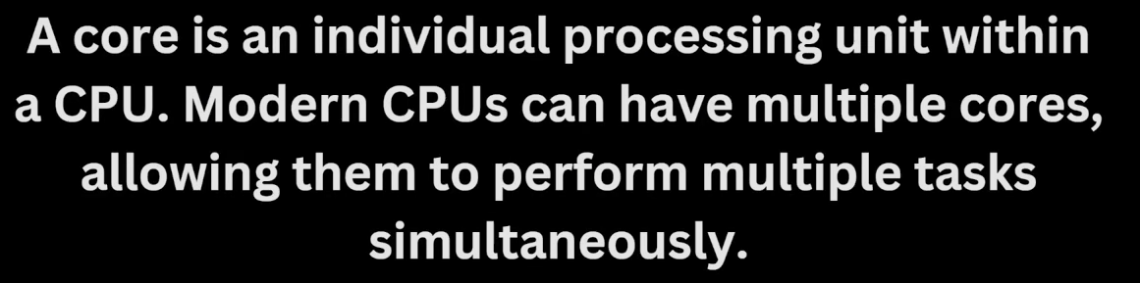

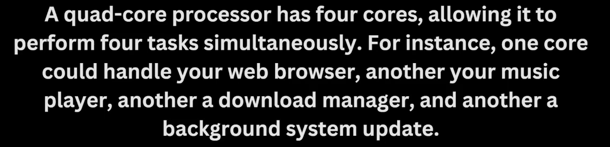

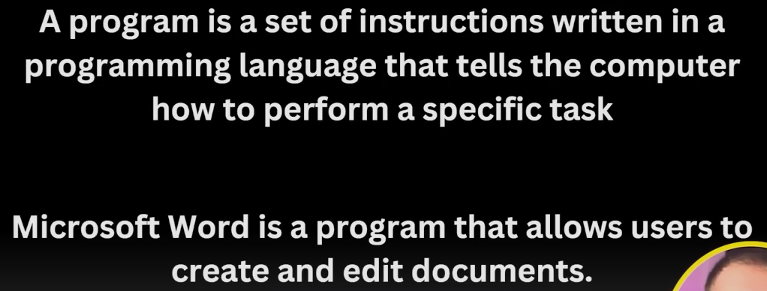

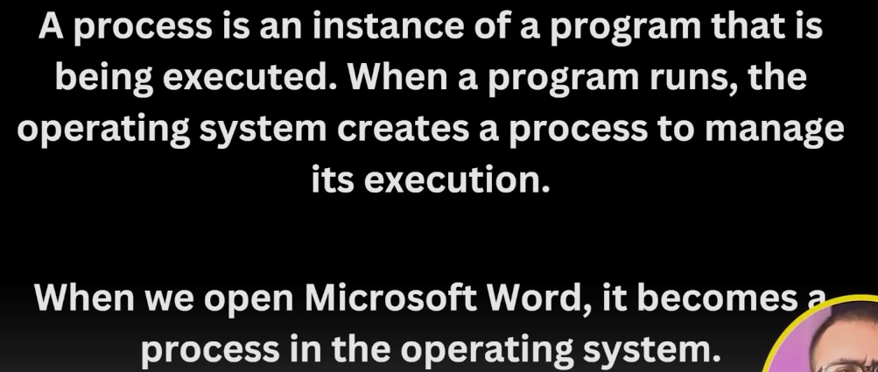

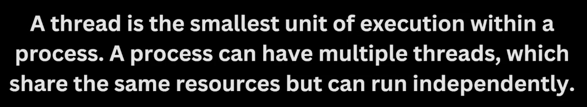

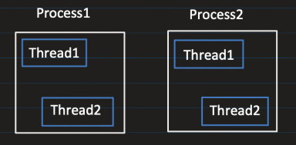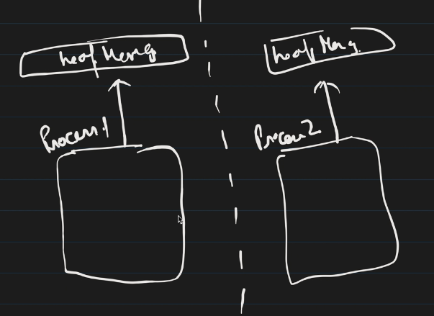

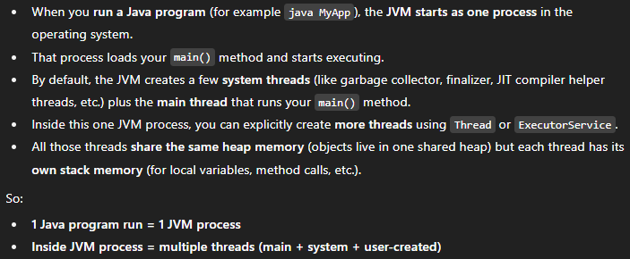

If you run: 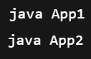You now have **two JVM processes**, each with: its own heap, garbage collector, its own thread stacks and metaspace. The bytecode is executed inside this JVM process

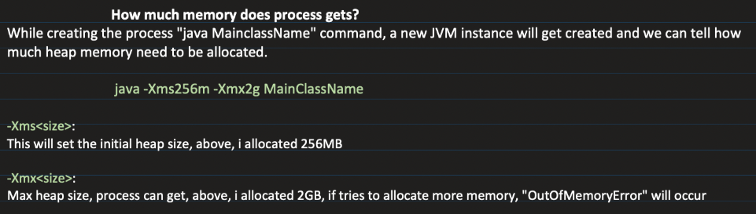

Using **-Xss2m** we can configure maximum stack size per Java thread. StackOverflowError if it exceeds.

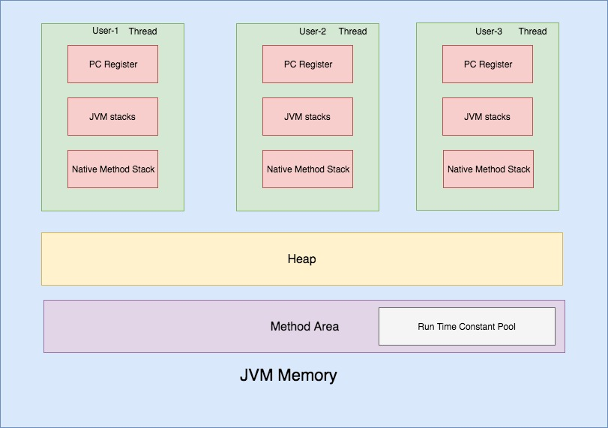

**PC register 🡪** stores the address of JVM instruction currently being executed for any particular thread. It points into the method’s bytecode stored in the Metaspace. It used during context switching.

For **native methods**, PC value is *undefined*

**JVM Stack** 🡪 A stack is created during a thread startup time. It stores **stack frames**. A new stack frame is created and pushed into a thread stack every time a method is invoked. A frame is popped when a method returns.

**Native method Stack** 🡪 Used when a thread executes **native (non-Java) code**

**Heap** 🡪 Objects created at runtime using “new” keyword are allocated in the heap and the stack stores the reference to it. The data stored in heap is not thread safe.

**Method Area / Metaspace 🡪** Once a class bytecode is loaded by a JVM class loader, the JVM creates an internal representation of the class and stores it in the *method area*. That internal representation of a class contains – method bytecode, attributes & field values, Runtime constant pool.

**Runtime Constant Pool** 🡪 It stores numeric constants, string literals symbolic references to methods and fields used in that particular class.

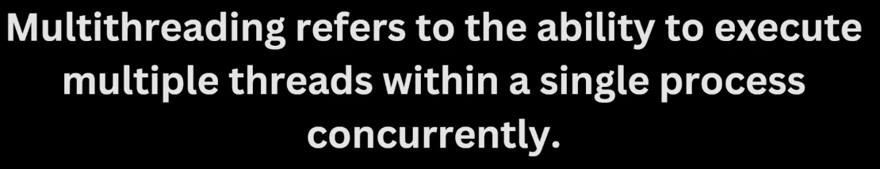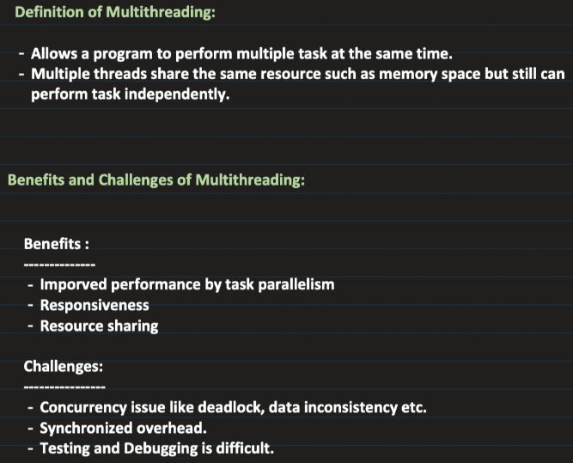

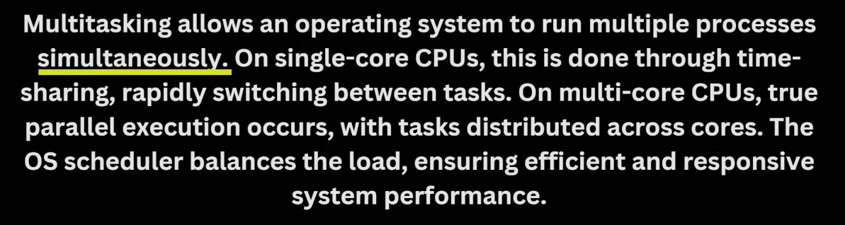

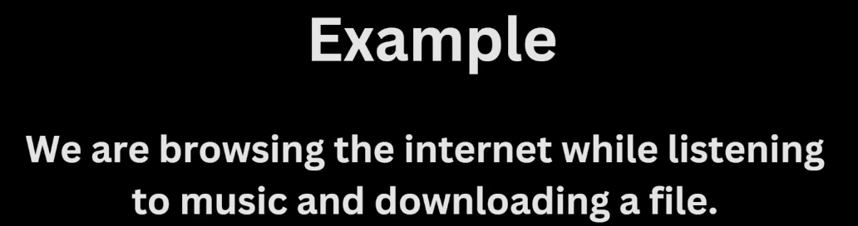

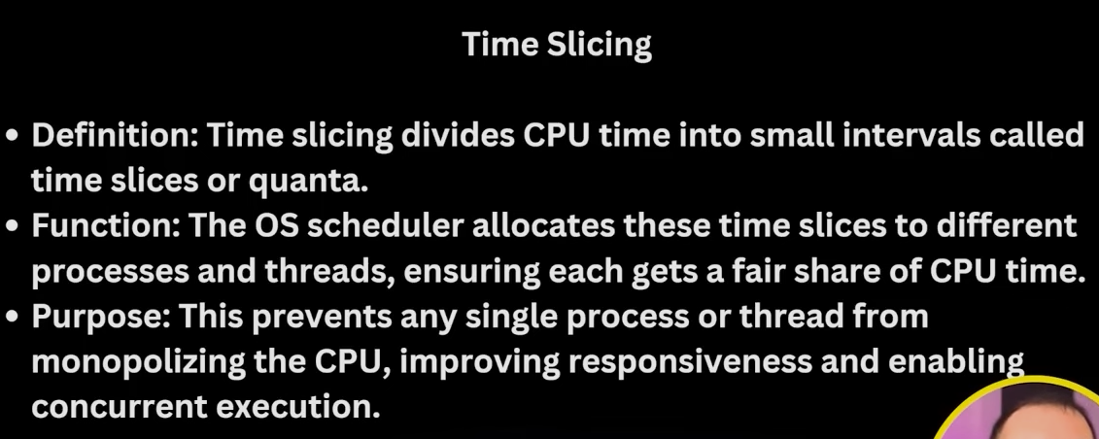

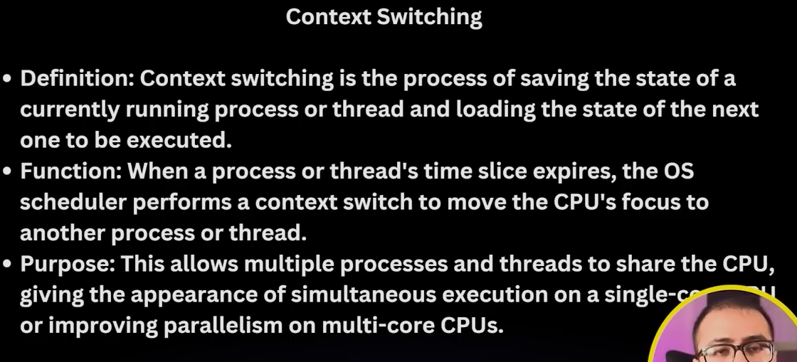

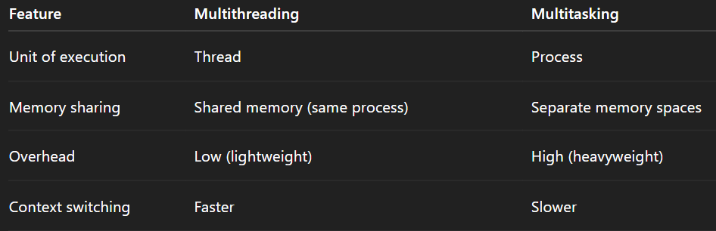

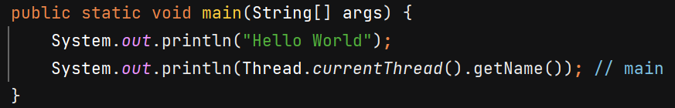

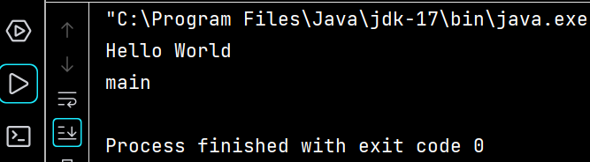



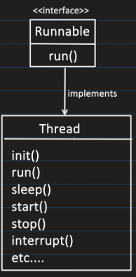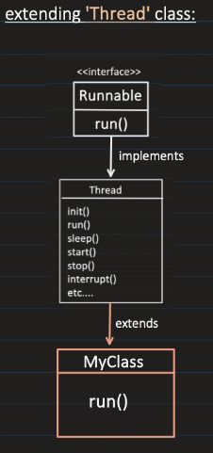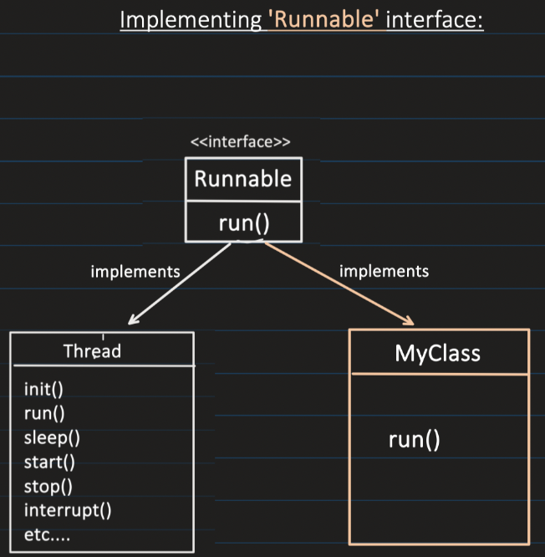

**Method 1 –**

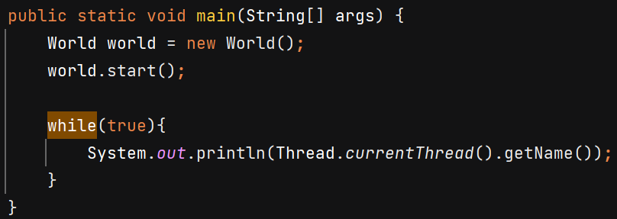

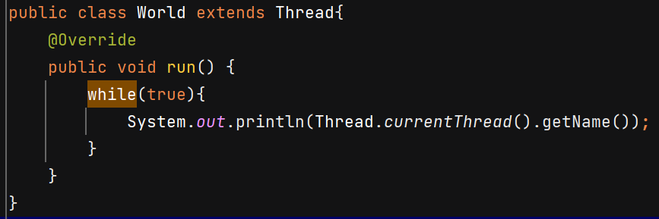

O/P - 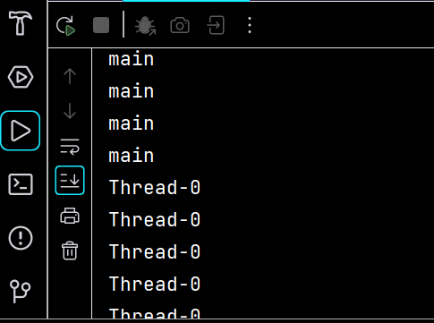

**Method 2** –

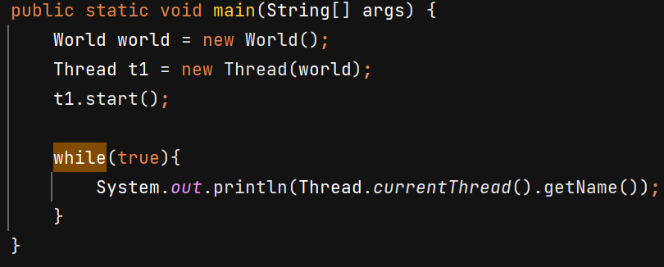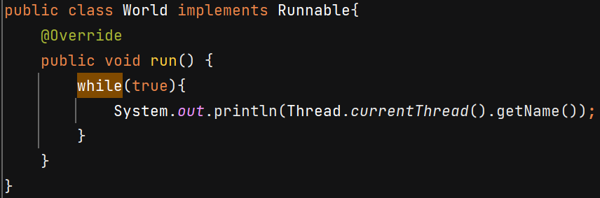



When we call the start() method, internally it calls the run() method of Thread class.

**Thread Lifecycle**

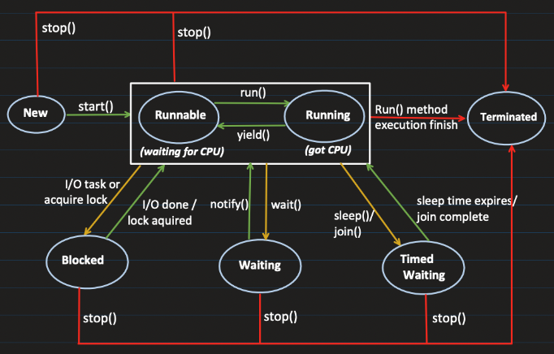

**New Thread:**When a new thread is created, it is in the new state. The thread has not yet started to run**.**

**Runnable State**: In this state, a thread might be ready to run or actually running.

**Blocked:** The thread will be in blocked state when –

* **I/O task:** like reading from a file or database
* **It is trying to acquire a lock** but currently the lock is acquired by the other thread.
* Release all the MONITOR LOCKS.

**Waiting state**: The thread will be in waiting state when it calls wait() or join() method. It will move to the runnable state when other thread will notify() / notifyAll(). Release all the MONITOR LOCKS.

**Timed Waiting**: A thread lies in a timed waiting state when it **calls a method with a time-out parameter** Ex- Thread.sleep(), join(timeout) and comes back to Runnable when timeout expires. DO NOT RELEASE MONITOR LOCKS

**Terminated**: The thread has completed execution.

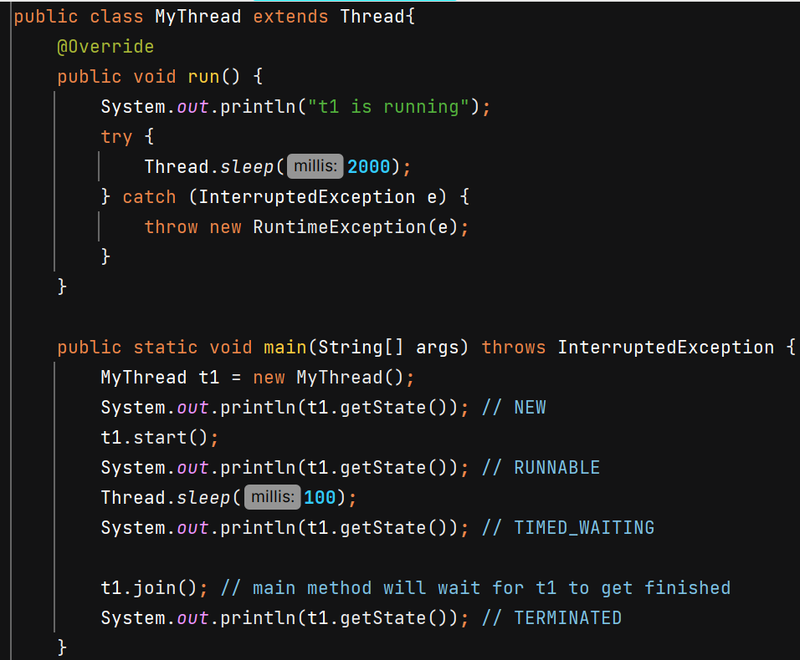

**Thread v/s Runnable**

Suppose class A already extends class B in that case we cann

ot extend it by Thread class also because multiple inheritance is not allowed, in this case class A should implement Runnable interface and override Run() method.

**Threads**

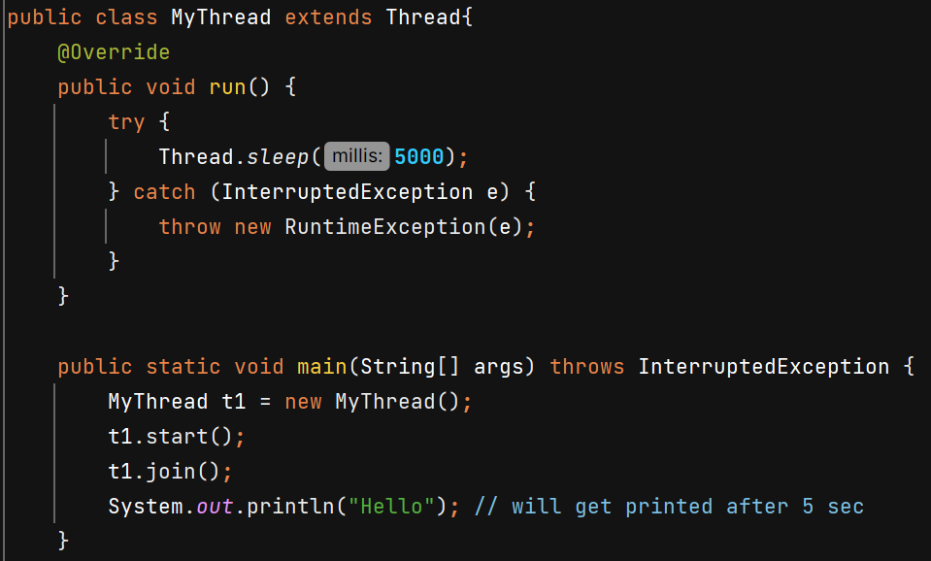

Join() will make main thread to wait for t1 thread to complete its execution.

join(timeout)

**Methods –**

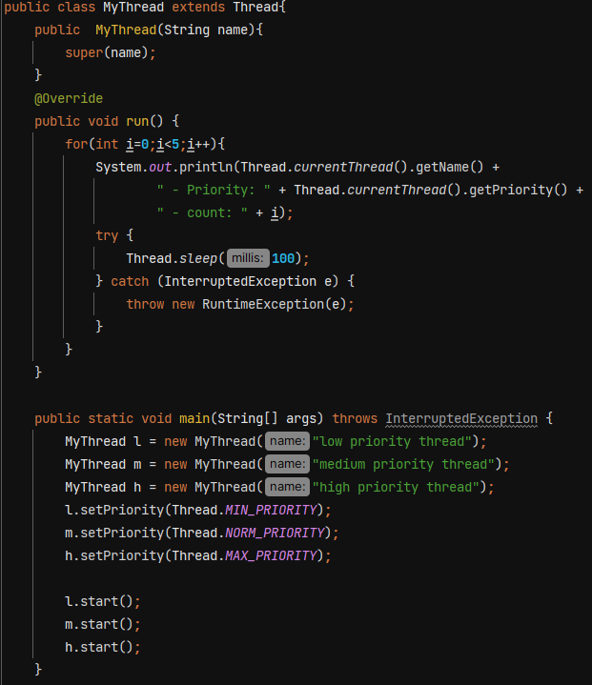

In constructor we can pass name of thread.

Using **setPriority(int priority)** we give hints to JVM about relative importance of threads, it is not strictly followed. Maybe thread with low priority execute earlier than thread with medium priority.

Default priority given to a thread is *NORM_PRIORITY* = **5**

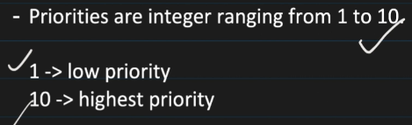

When a new thread is created, it inherits the priority of its Parent method.

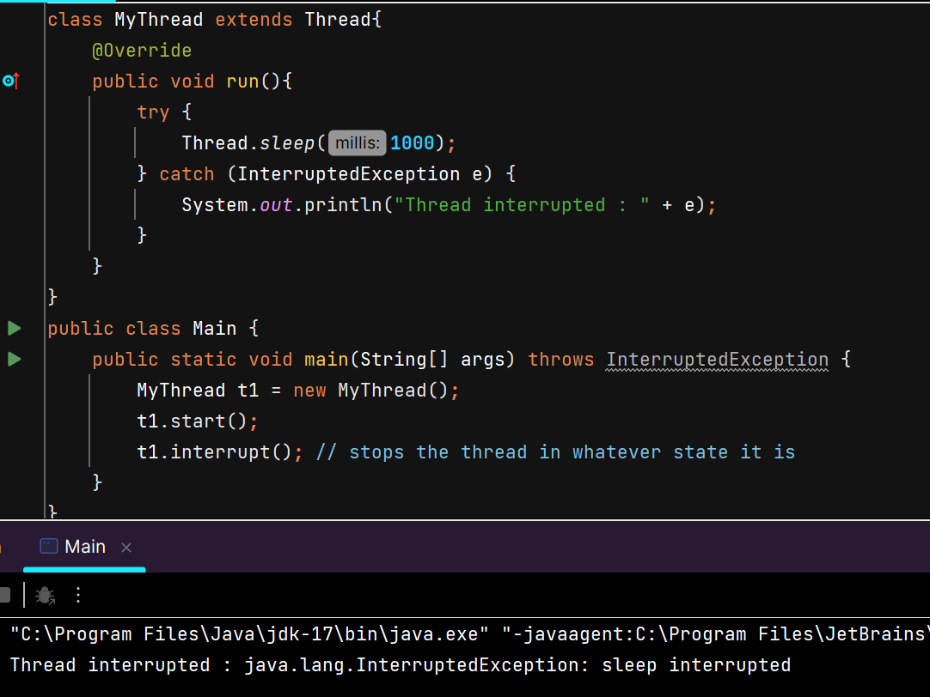

**t1.interrupt() -**



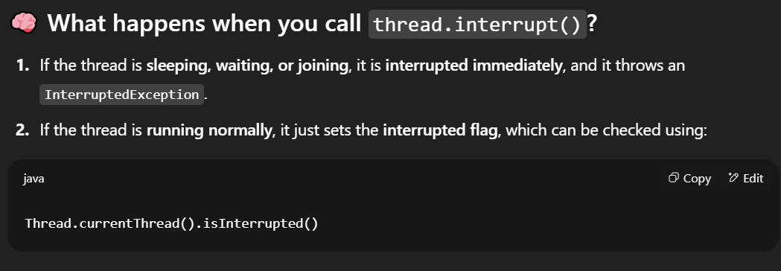

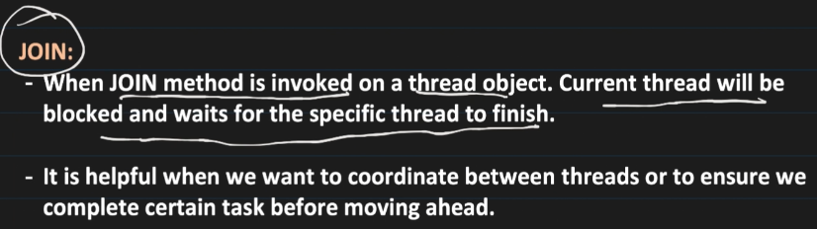

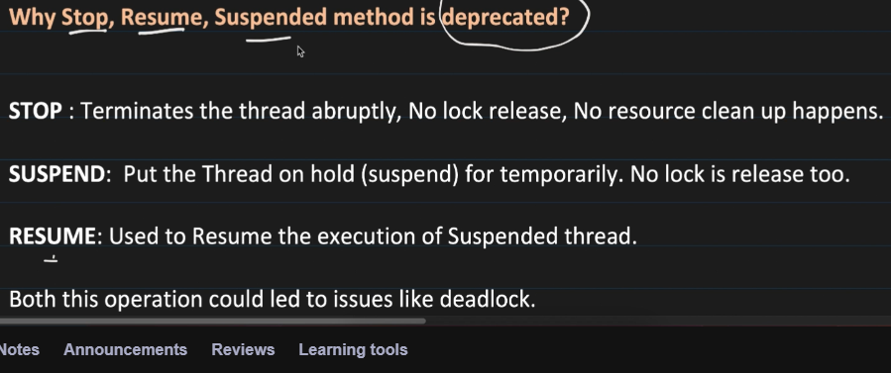

**Yield()** - Used to hint to the thread scheduler that the current thread is **willing to pause** its execution and **current use of processor**to let other threads run. The scheduler is free to ignore this hint.

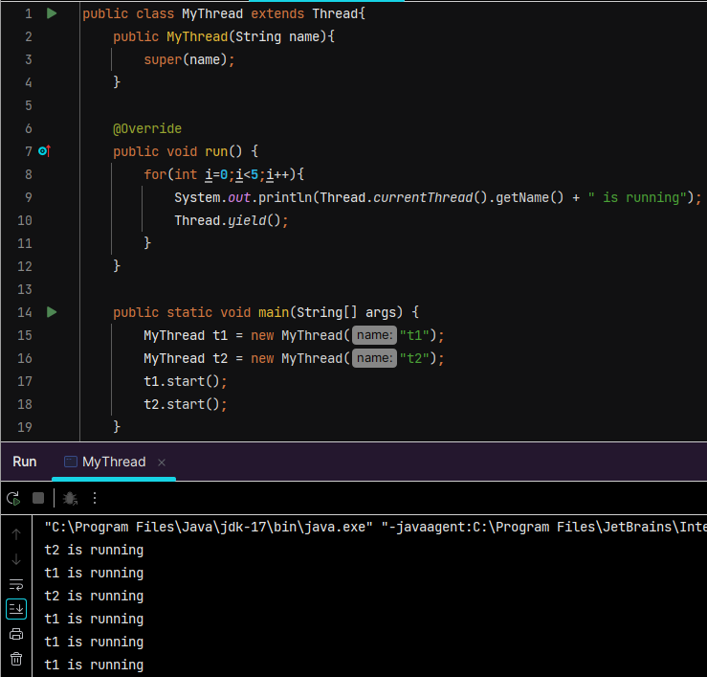

**User Thread** – Any **normal thread** that performs the **main work of the application**. Whatever work we are performing inside run() method are done with help of user threads.

The **JVM will continue running** as long as there is at least **one user thread** still active — it **waits for all user threads to finish** before shutting down.

**Daemon Thread** – they run in background. Ex- garbage collector in Java.

**JVM does not wait** for them to finish before shutting down. As soon as main thread, all other user threads are done, daemon threads are also terminated and JVM terminates.

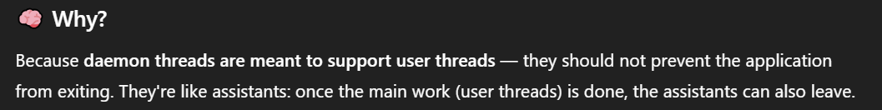

The daemon status of a thread (set via setDaemon(true)) must be configured before the thread is started.

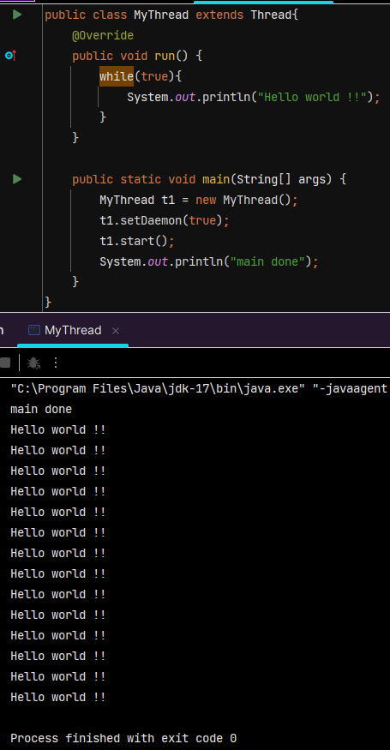 

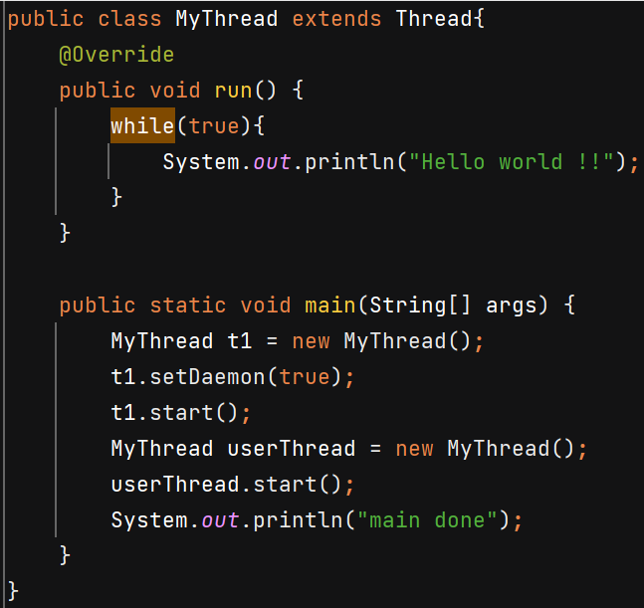

In this case both threads keep running and JVM will wait for userThread to finish.

**Synchronization**

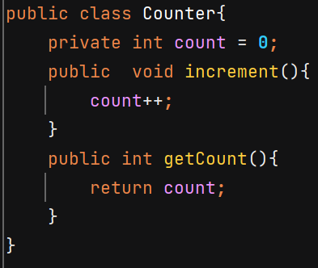 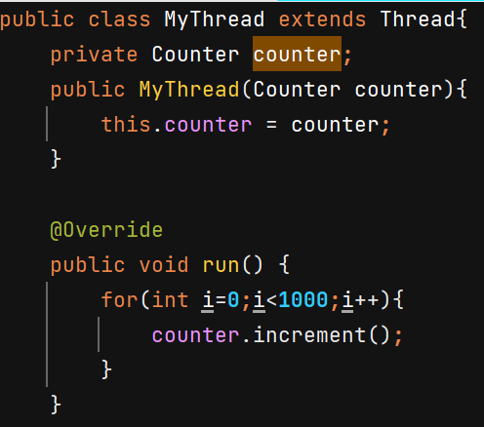

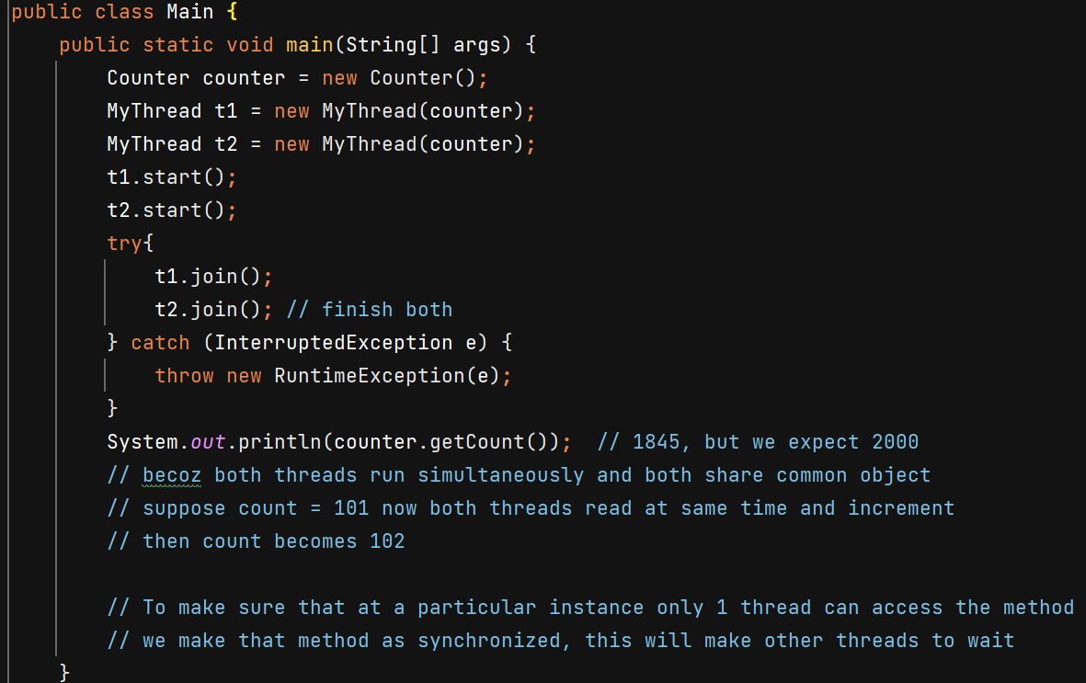

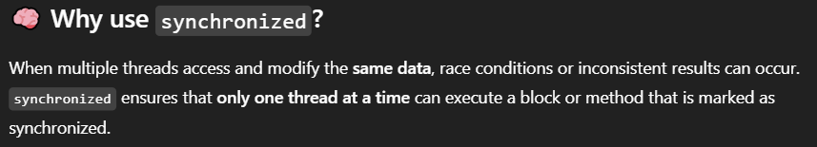

**Synchonized instance methods** 🡺 Only **one thread per object instance** can execute this method at a time. Monitor lock of that particular instance is acquired.

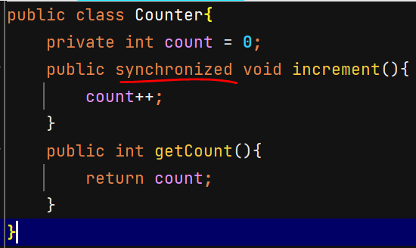 Now O/P – 2000

Instead of whole method we can make a particular **block synchronized** –

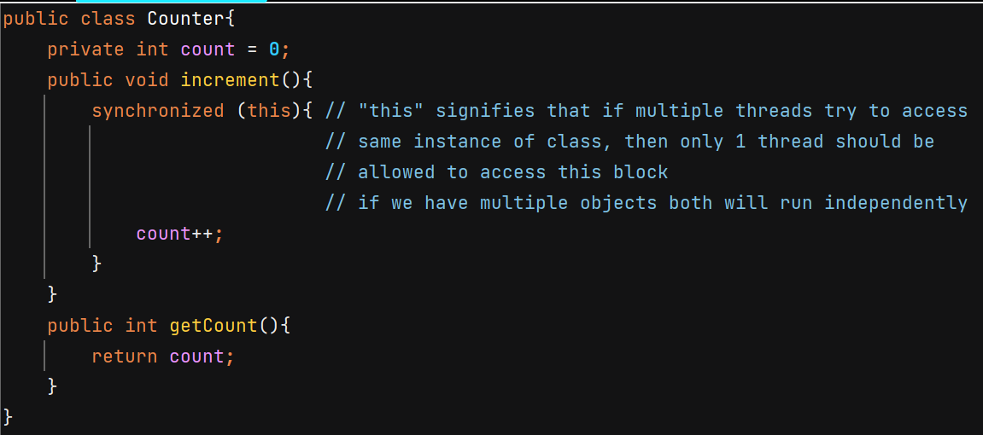

Both **synchronized(ClassName.class)** and a **static synchronized method** use the class-level lock – locks class object.

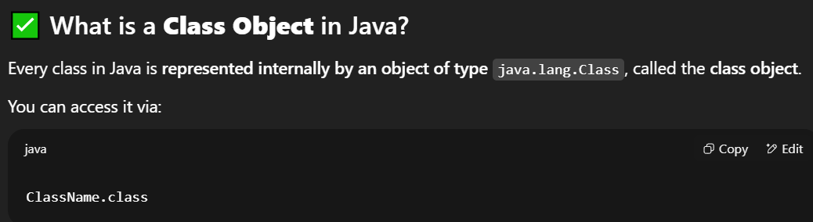

**synchronized(object)** 🡺 acquires intrinsic lock of that object

**Critical section** – Part of our code where shared resources are accessed and modified. Ex- increment() method in above example.

**Race Condition** – when multiple threads are working on shared resources and if their timing conflicts it can lead to unexpected results.

**Mutual Exclusion** – condition when only 1 thread can access the critical section

**Locks** – after using synchronized keyword on method we achieve mutual exclusion it is done by locking. When 1 thread is working on shared resource it aquires the lock and when it is done, it releases the lock.

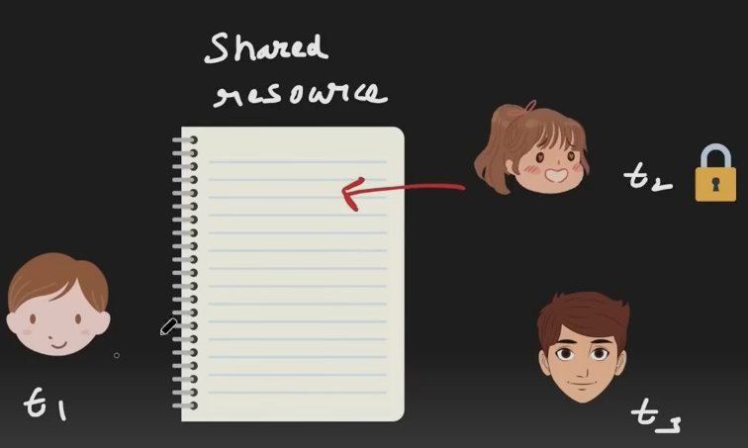

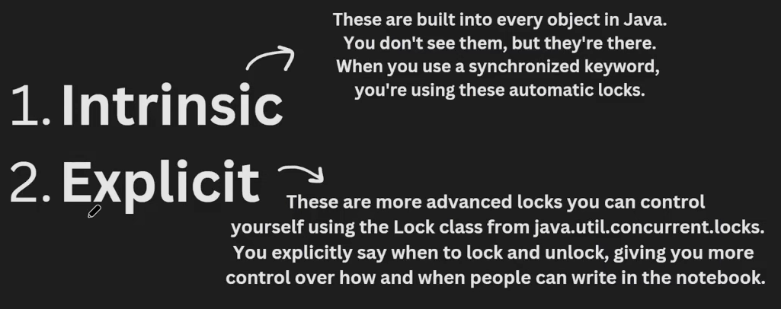

An **intrinsic lock** (or monitor lock) is a **built-in synchronization mechanism** that every Java object has. It helps to make sure that only 1 thread goes inside the particular seciton of code (synchronized block or method)

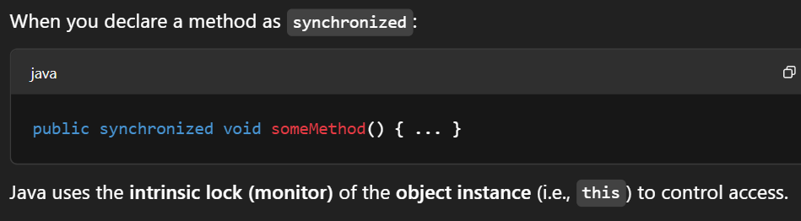

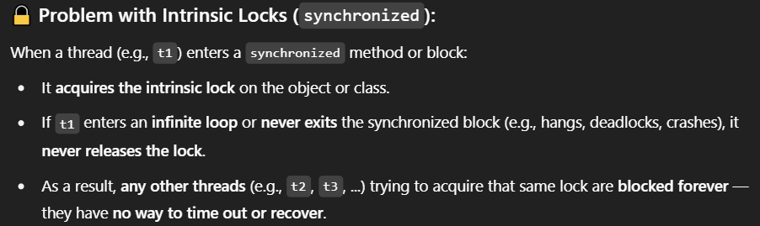

You can’t interrupt a thread that’s waiting on a synchronized block/method.

Explicit locking can solve it.

**Lock** is interface and **ReentrantLock** is its impl class.

Lock.lock() 🡪 Acquires the lock **if available**, otherwise thread will wait for acquiring lock in BLOCKED state, just like synchronized.

.tryLock() 🡪 Acquires the lock if it is available and returns immediately with the value true. If the lock is not available then this method will return immediately with the value false. Prevents deadlocks by not waiting forever.

.tryLock(**1000,** TimeUnit.*MILLISECONDS*) 🡪 Acquires the lock if it is free within the given waiting time and the current thread has not been interrupted. If the lock is available this method returns immediately with the value true.

.unlock 🡪 Releases the lock. Should **always be in a finally block** to ensure it’s released.

**Note** – The reason why Sonar suggests to re-interrupt the thread is because by the time the exception occurs, the thread's interrupted state may have been cleared, so if the exception is not handled properly the fact that the thread was interrupted will be lost.

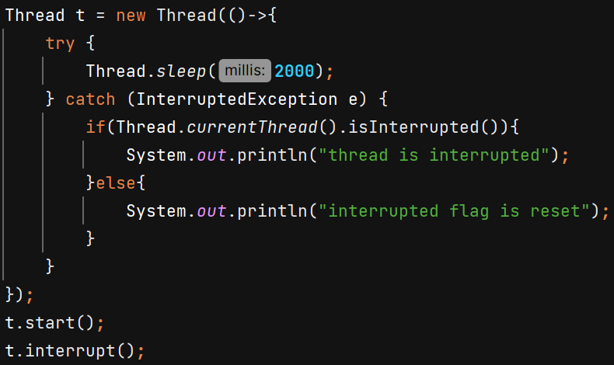 O/P – interrupted flag is reset

Example –

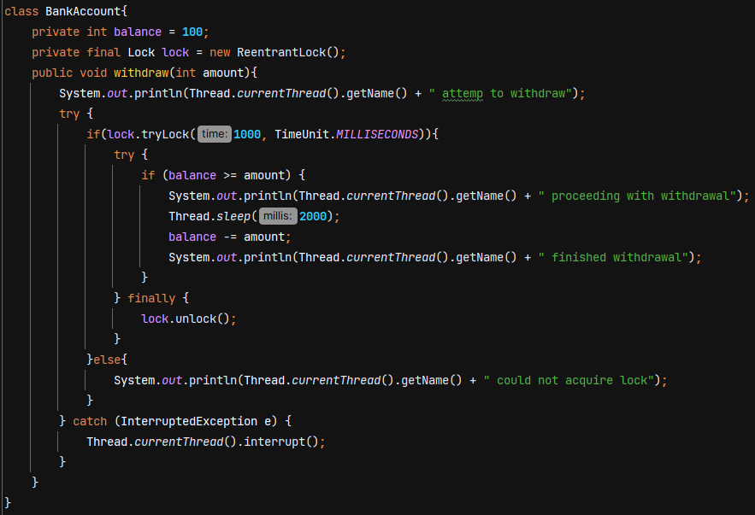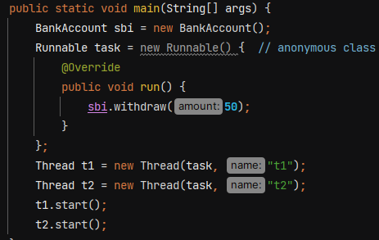 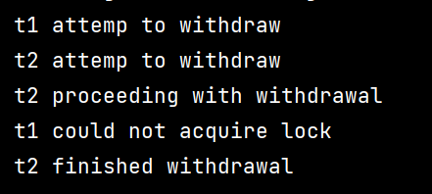

**Deadlock**

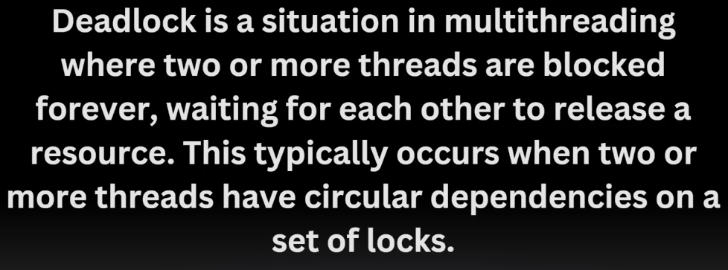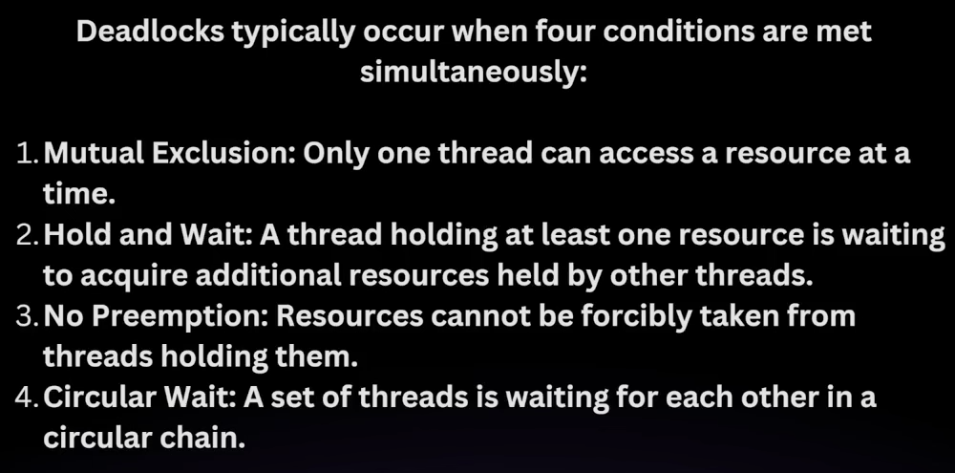

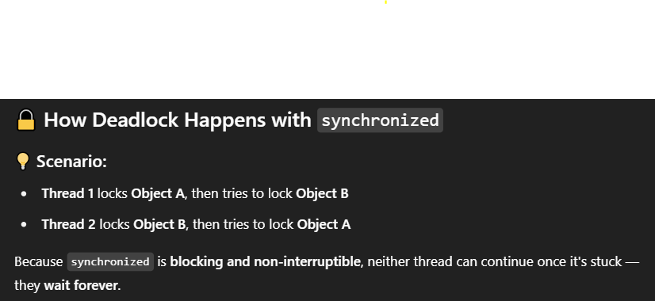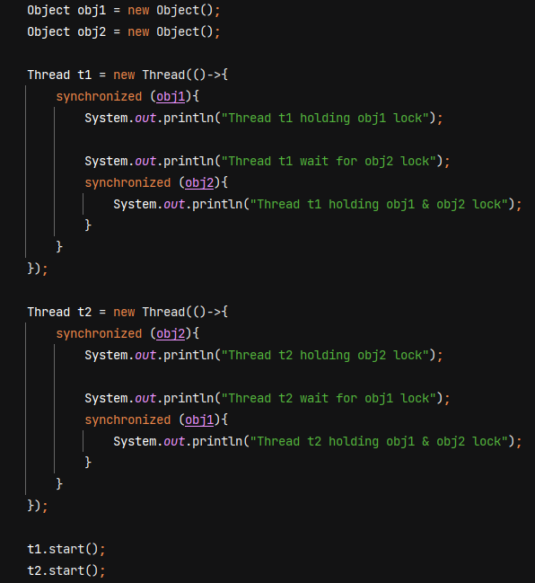

Example –

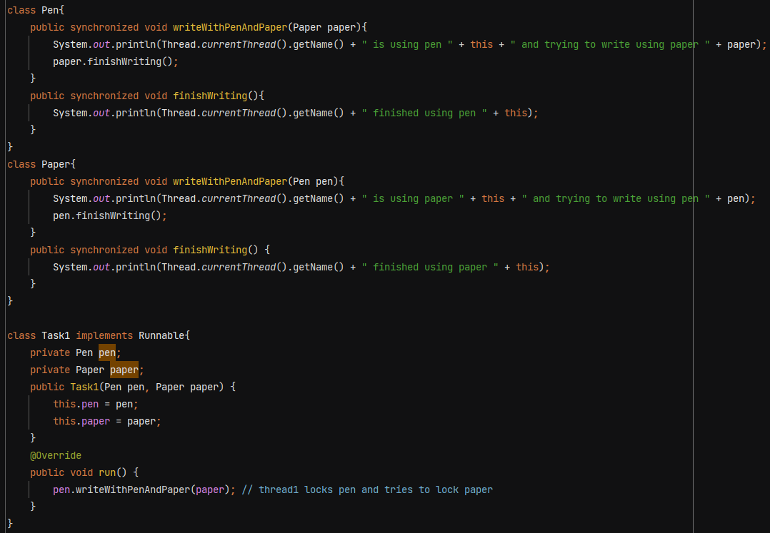

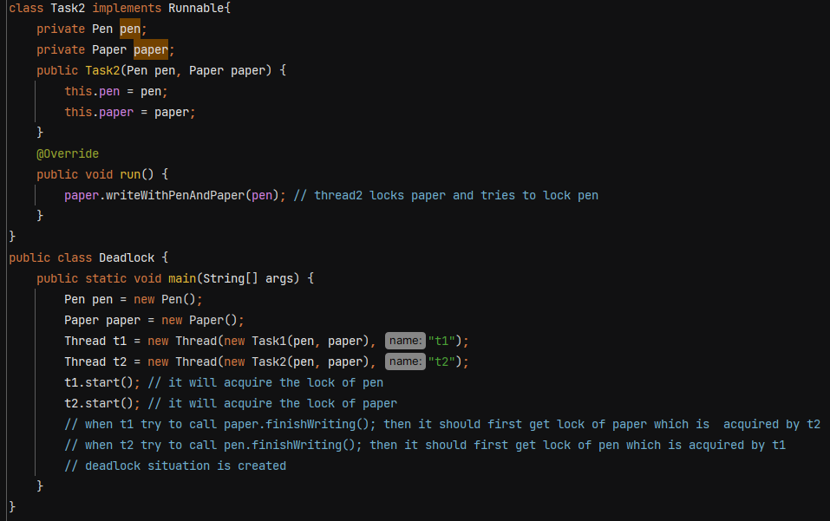

To avoid deadlock, ensure that all the threads acquire locks in consistent order.

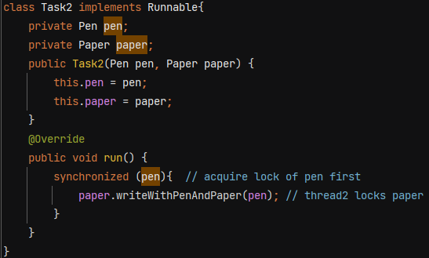

This will ensure that t2 will run only when it locks both pen and paper

**Deadlock Prevention in ReentrantLock**

If a thread has acquired a lock, it can acquire the same lock again, without blocking.

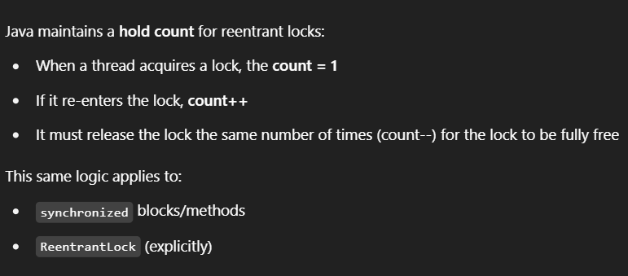

Java's intrinsic locks (used with synchronized) are also reentrant.

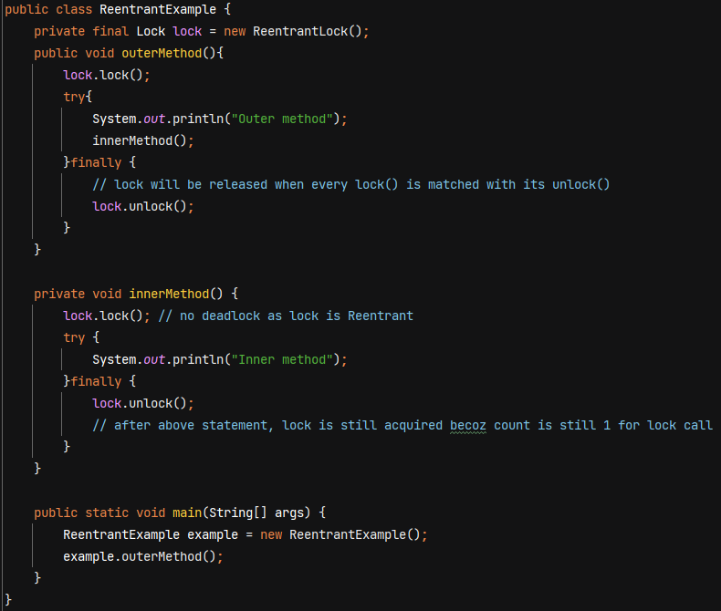

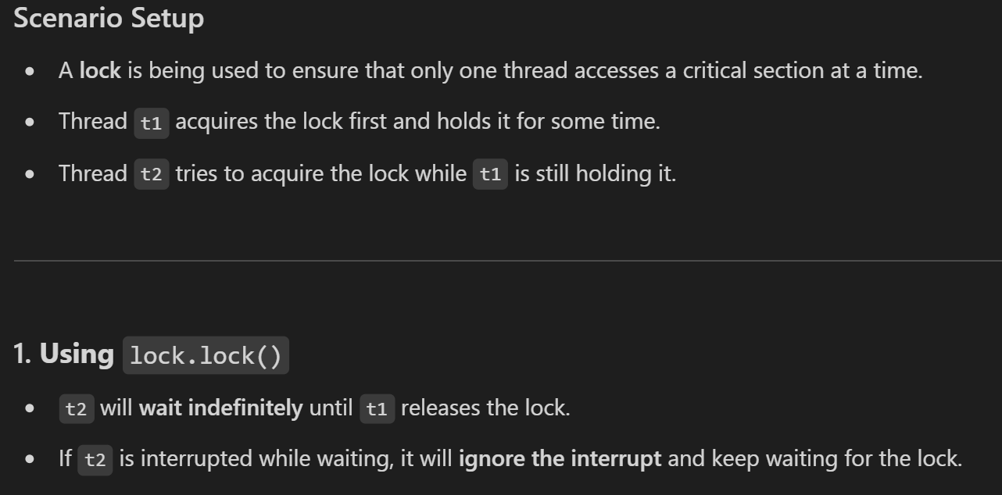

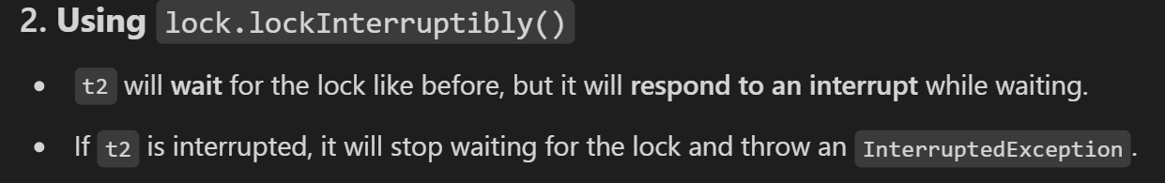

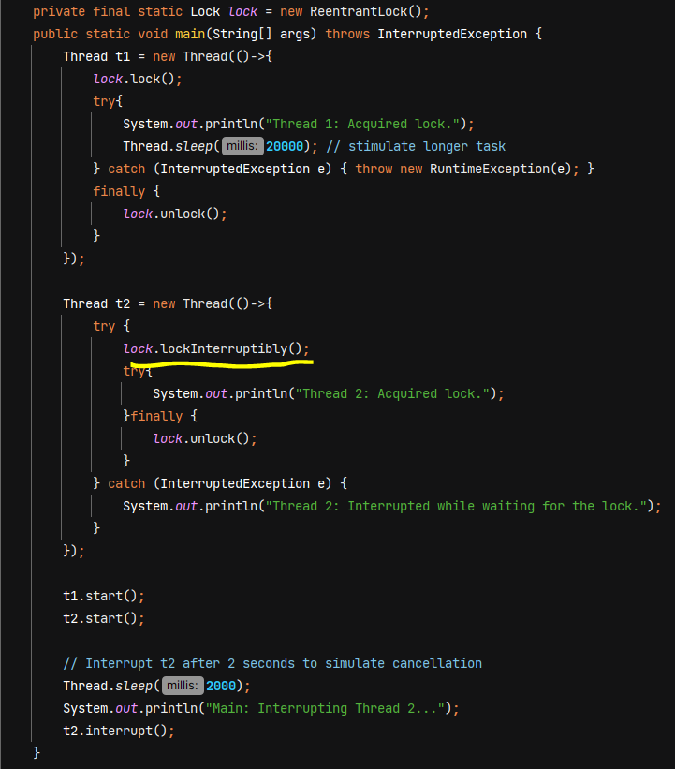

O/P - 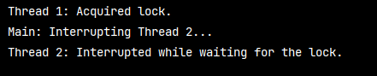

**Lock’s Fairness**

* A fair lock ensures that threads acquire the lock in the order they requested it  
  (i.e., a first-come, first-served basis)
* A thread will not starve (i.e., will not have to wait indefinitely) because threads that arrived earlier in the queue are guaranteed to get the lock before any new threads.
* A non-fair lock (when fairness is set to false) does not guarantee order
* By default value is false.

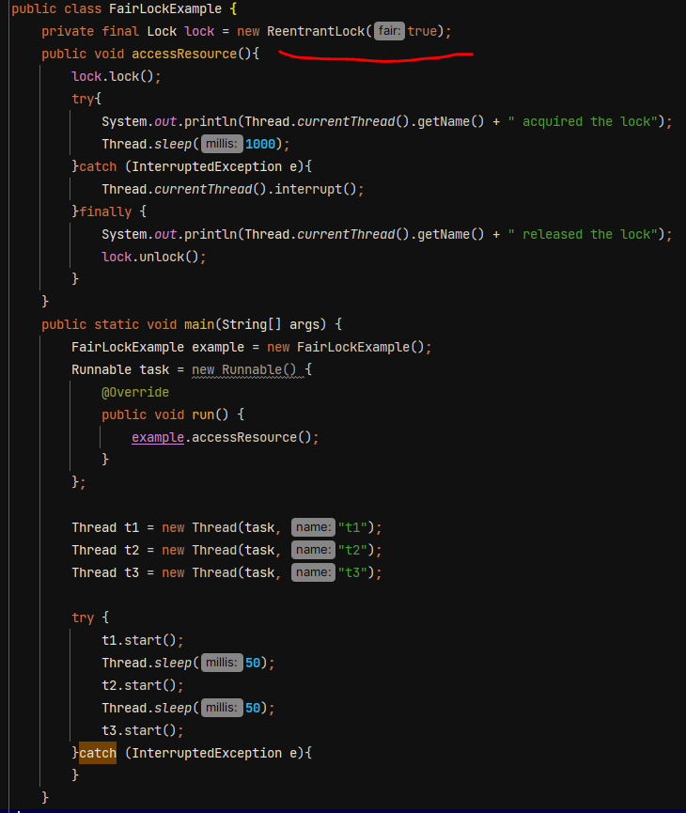

Problems with Synchronized –

* No fairness
* indefinitely blocking to acquire lock
* No Interruptibility
* No distinguish between read /write operations – synchronized will block every thread.

**ReadWriteLock** – it allows multiple threads to read resources concurrently (shared lock) as long as no thread is writing to it. It ensures exclusive access for write operations. (exclusive lock)

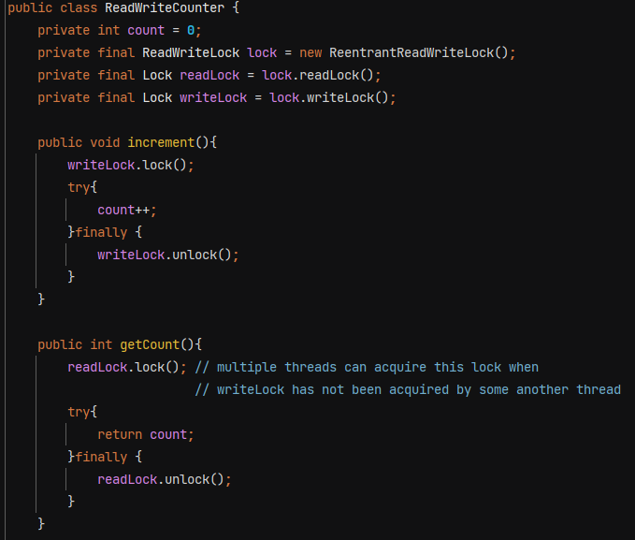

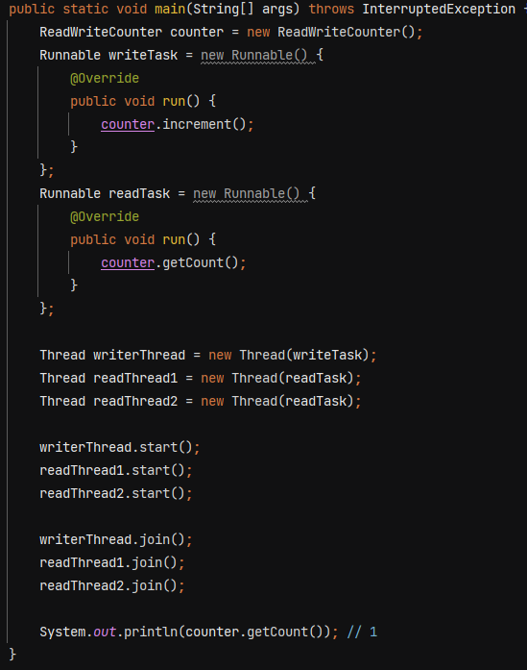

If no of read is very high compared to write, then ReadWriteLock is a better solution.

**Types of Locks –**

1. **Pessimistic** – synchronized, reentrant, ReadWriteLock are all pessimistic where we put the shared or exclusive lock.
2. **Optimistic** – There is no lock acquired

Ex – consider db row

Whenever a new row is inserted its row version is 1 and whenever any update happens it keeps on incrementing.

If t1 and t2 both want to access the same row –

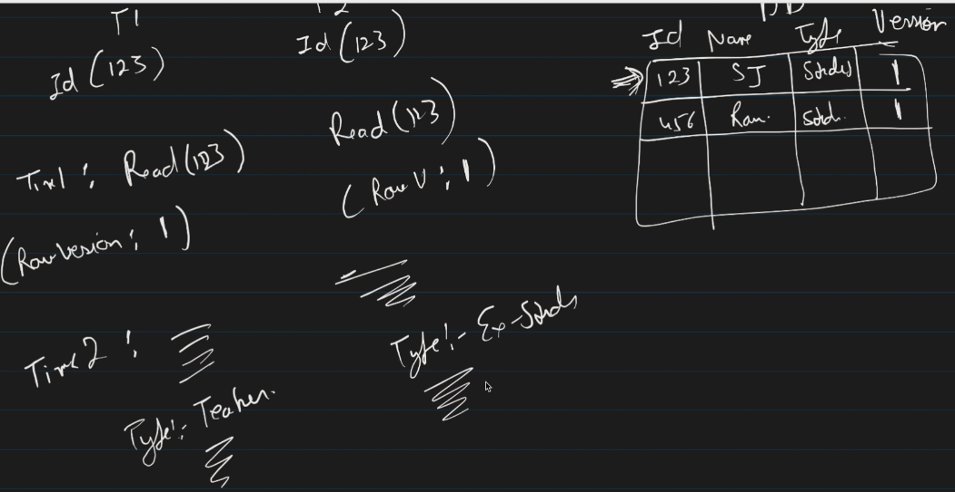

Now at Time3: thread 2 will try to update the row and check if still the row version is 1? Becoz when I read it row version was 1.

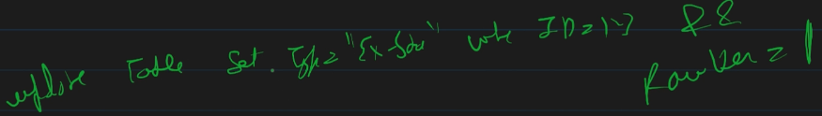

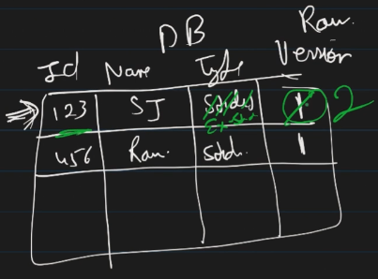

Now at Time4: thread 1 try to update the row

Update table set type =’teacher’ where id=123 && rowVersion=1

This query will fail so thread 1 will rollback and retry previous steps like first reading the row with id=123 this time it has RowVersion=2 and then perform updates.

So Optimistic locking is working by saving the lock state / RowVersion whenever you read the data.

**StampedLock –**

stamp is like state of the lock and **lock.validate(stamp)** method will return false if in mid anyone has changed the state of lock otherwise true.

1. Support Read/Write Lock functionality like ReadWriteLock

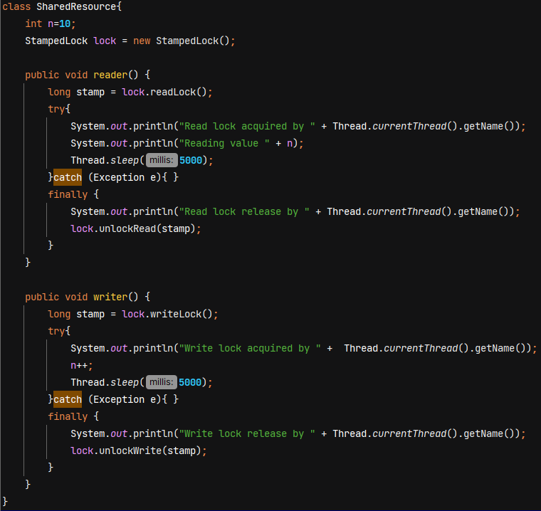

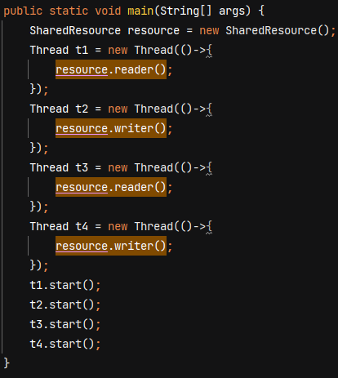 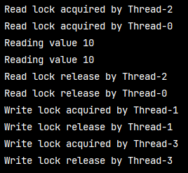

1. Support Optimistic Lock functionality too

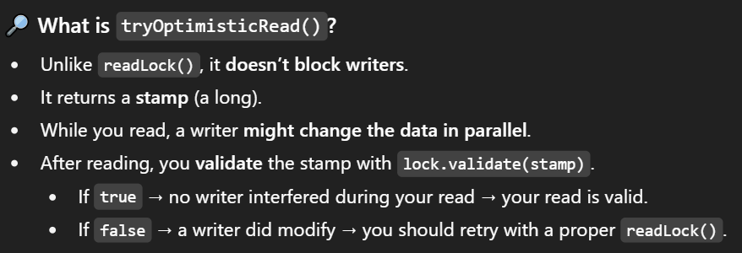

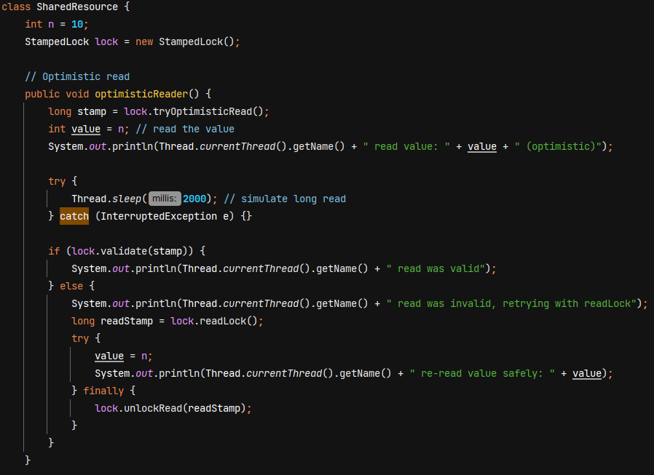

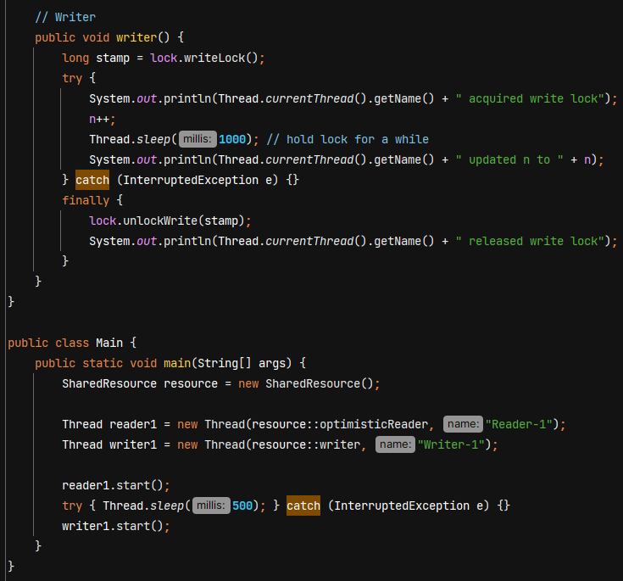

O/P - 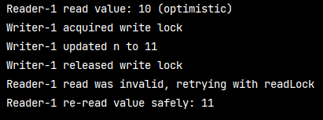

**Semaphore** – It *is a synchronization tool that controls how many threads can access a shared resource at the same time. Unlike a lock (which allows only one thread), a semaphore can allow multiple threads, depending on the number of permits given in its constructor.*



Ex- Used in Printer Queue, if an office has **2 printers**, only **2 people** can print simultaneously. Semaphore with 2 permits is used to control access. The 3rd person who tries to print waits until one printer is free.

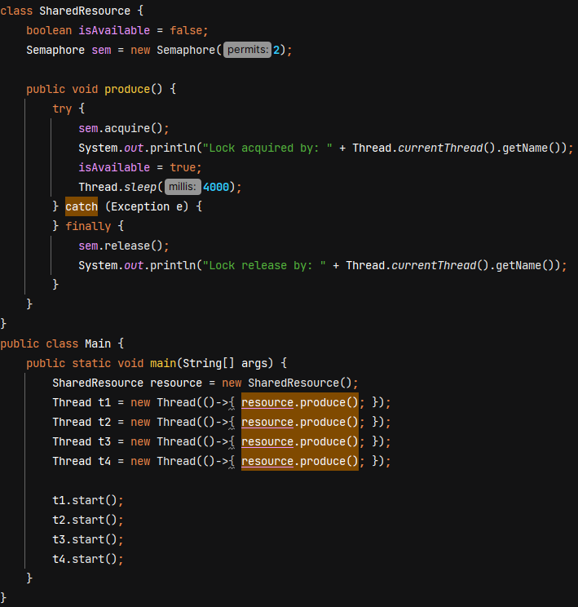 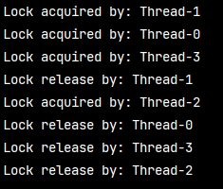

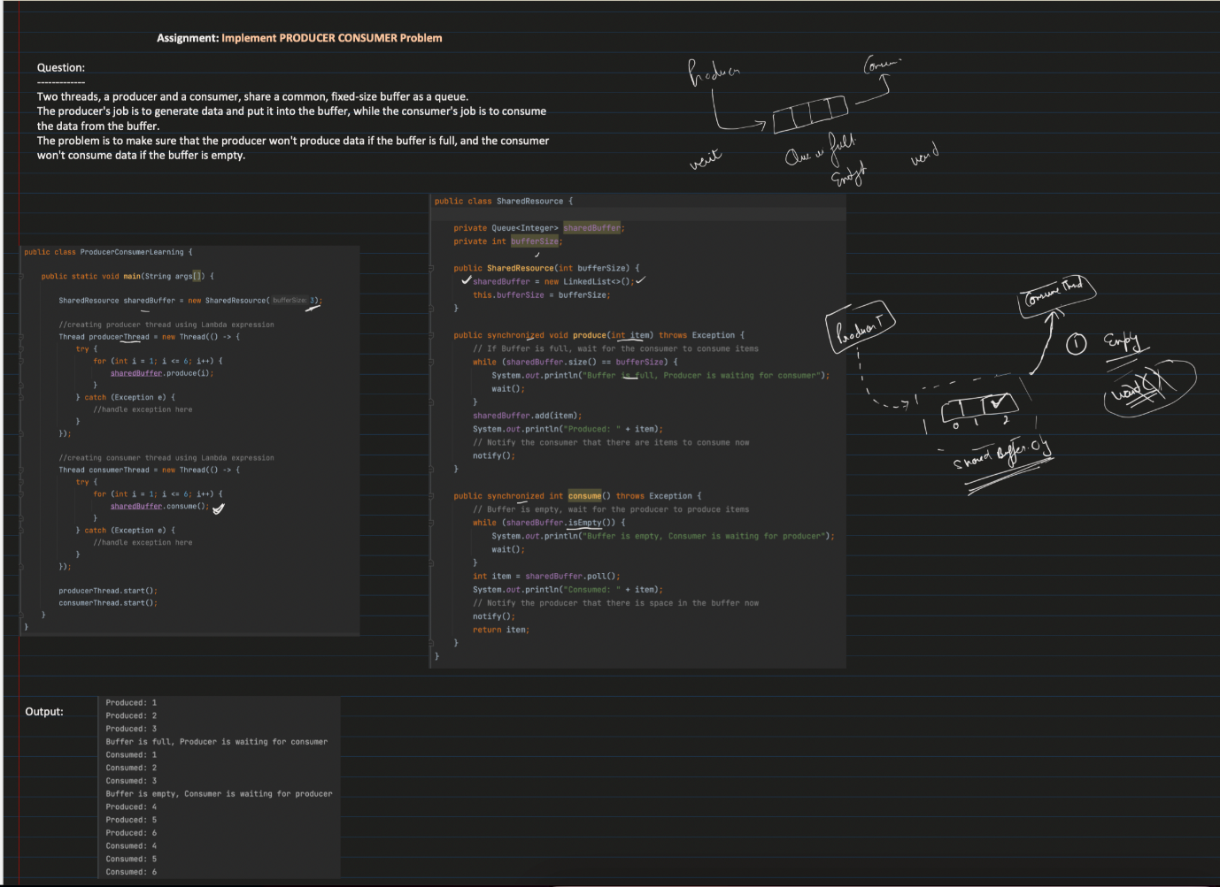

**Thread Communication**

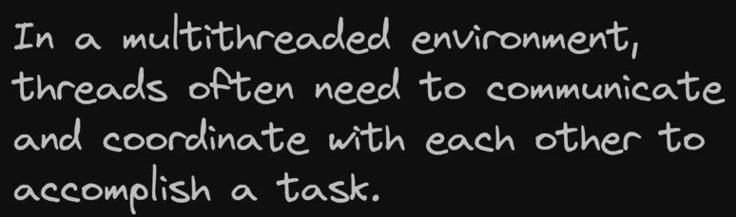

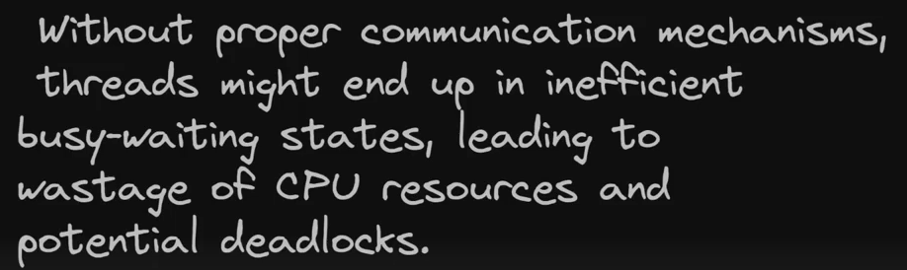

For thread communication, we have methods like wait(), notify() and notifyAll(). These methods belong to the **Object class**, not Thread.

Wait() 🡪 tells current thread to release the lock and wait until some other thread run notify() or notifyAll()

Notify() 🡪 wakes up a single thread that is waiting

NofityAll() 🡪 wakes up all threads that are waiting

These methods can only be called within a synchronized context. When you use methods like wait(), notify(), or notifyAll() on an object, the **calling thread must own that object's intrinsic lock**.

Ex- 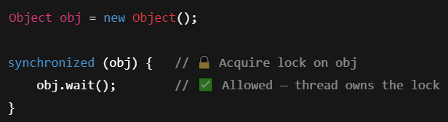

Ex- We want Producer to produce data but wait if hasData is true. And Consumer should consume data when hasData is true.

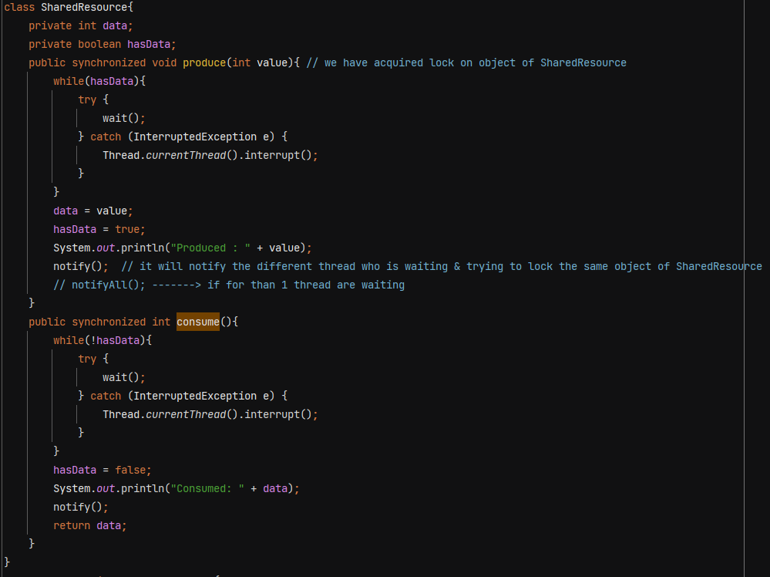

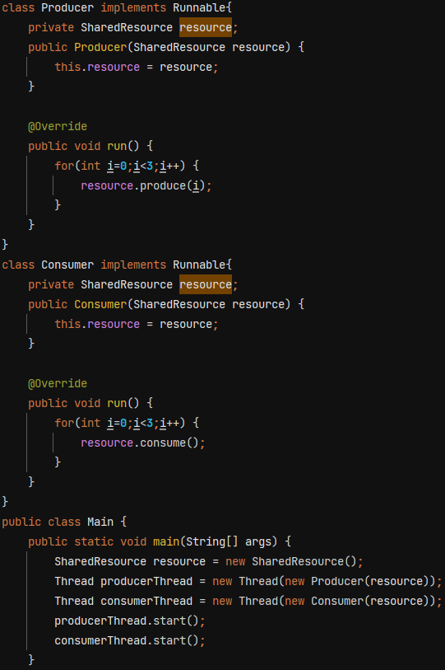 O/P 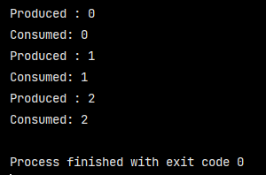

**Thread Communication in ReentrantLock/ ReadWriteLock –**

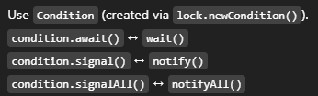

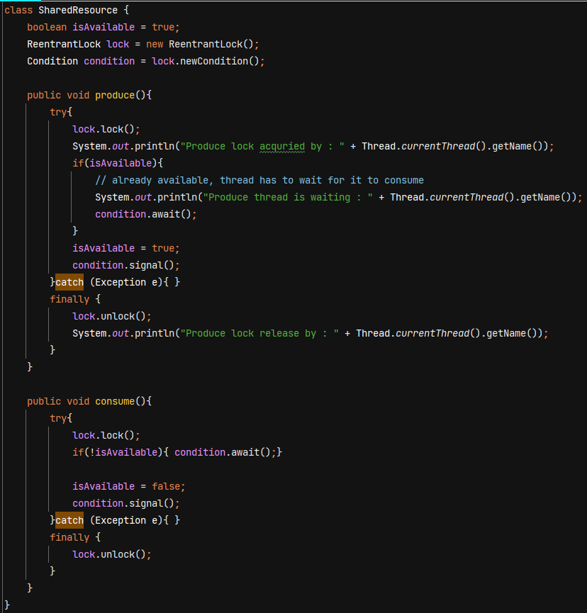

**Thread Safety** – a code is thread safe if it gaurantee no unexpected results, no race condition when multiple threads try to access that piece of code with same object.

**Lambda Expression** – anonymous function 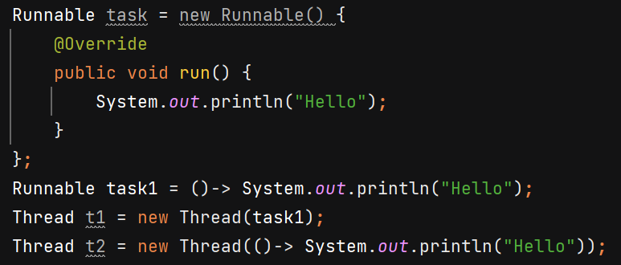

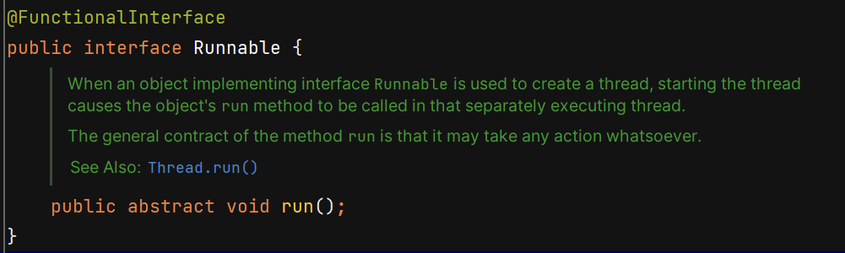

Suppose an API is having load of 100 hits per second -

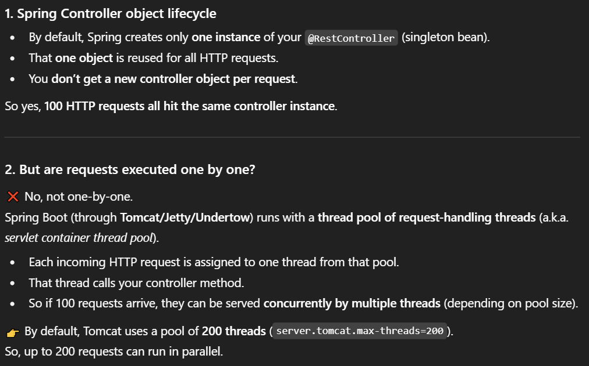

<https://hackernoon.com/multi-threading-in-spring-boot-with-executorservice-and-completablefuture>  
  
<https://medium.com/@nidhiupreti99/introduction-to-multithreading-java-spring-boot-b4930b73f302>

**Thread Pool** – It’s a collection of reusable worker threads that are ready to perform a task concurrently.

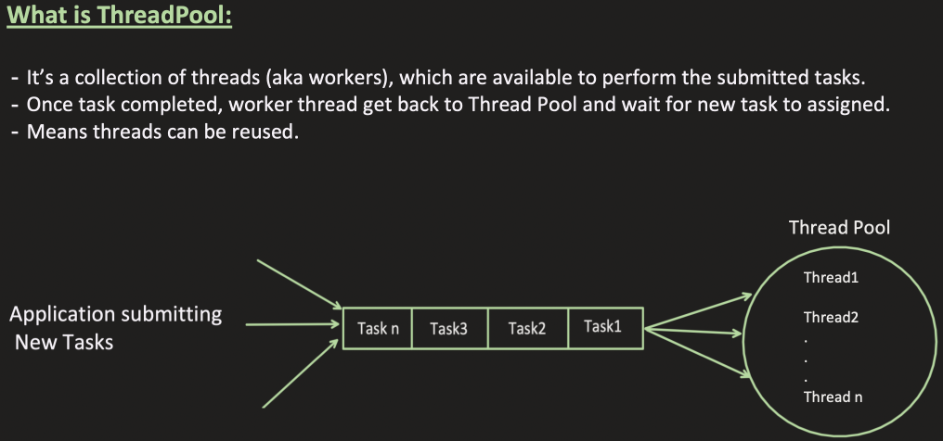

1. Resource management – every time creating and destroying threads is expensive. Thread creation takes time because certain memory allocation needs to be done.
2. Control over thread count – puts a limit on no of threads that can be created.

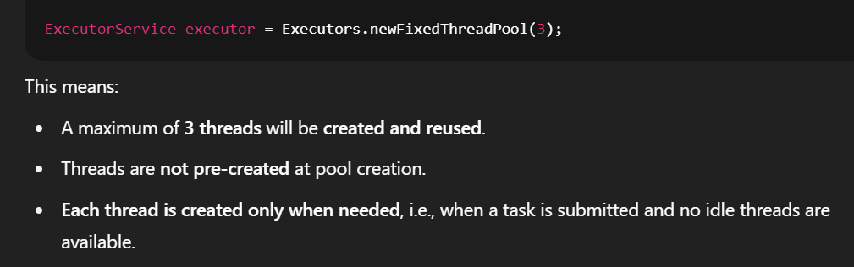

1. 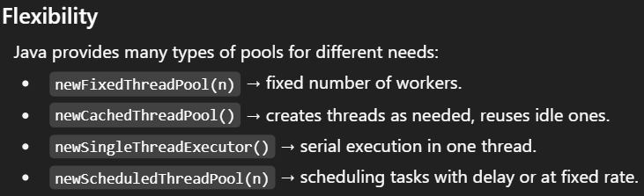
2. **Faster Response**: Tasks don't have to wait for a new thread to be created. They can be executed immediately by a waiting thread from the pool.

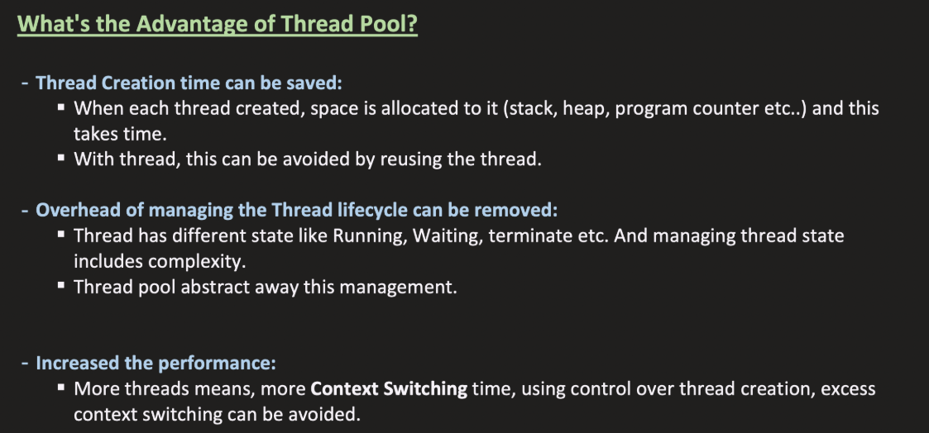

**Executors Framework**

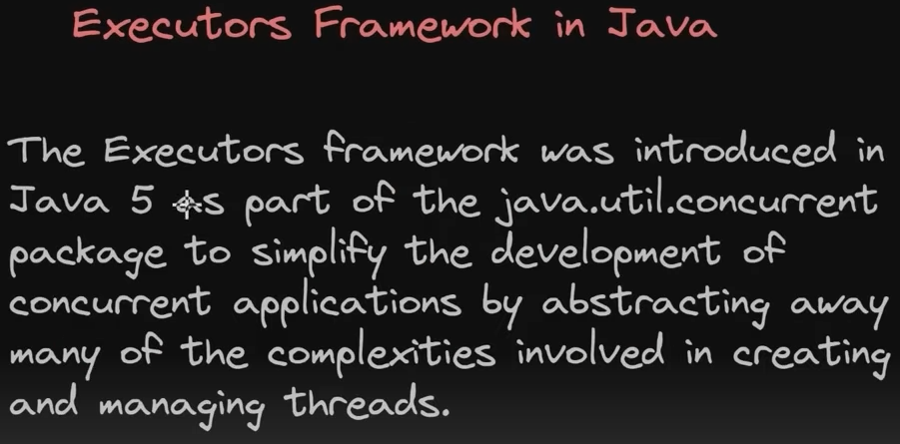

Problems prior to Executors framework - 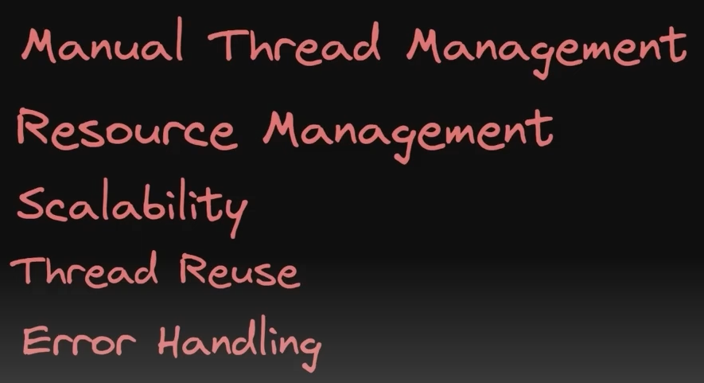

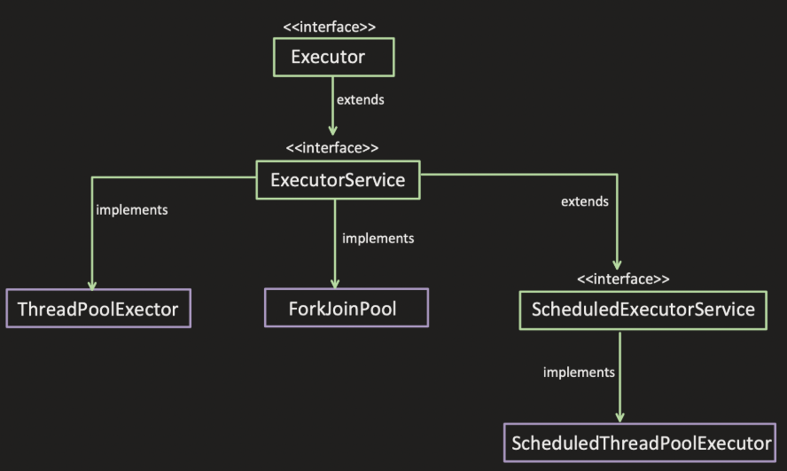

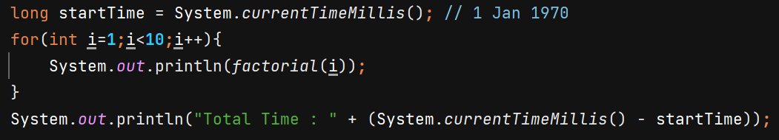

O/P- Total Time : 4575 ms

Using multithreading 🡺 O/P – 515 ms

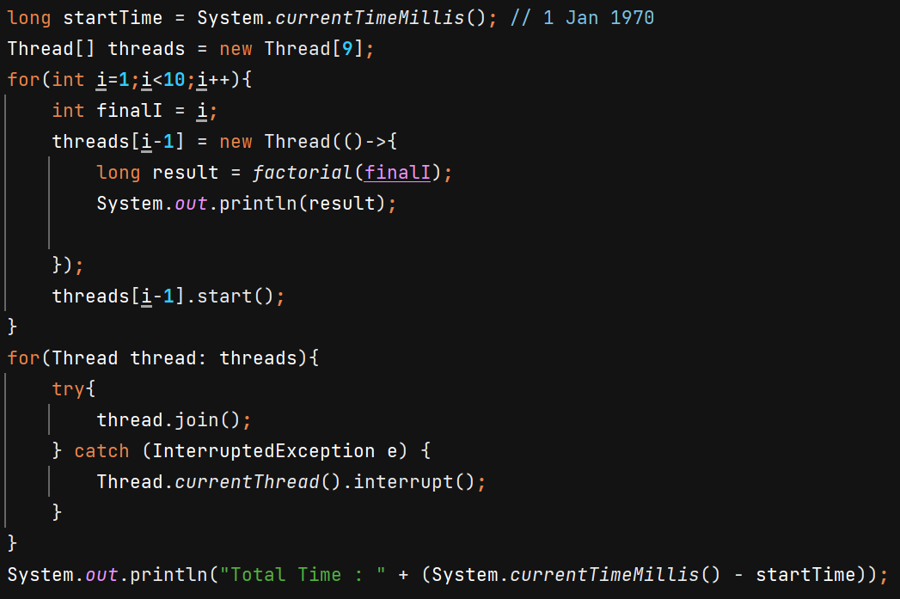

**ThreadPoolExecutor**

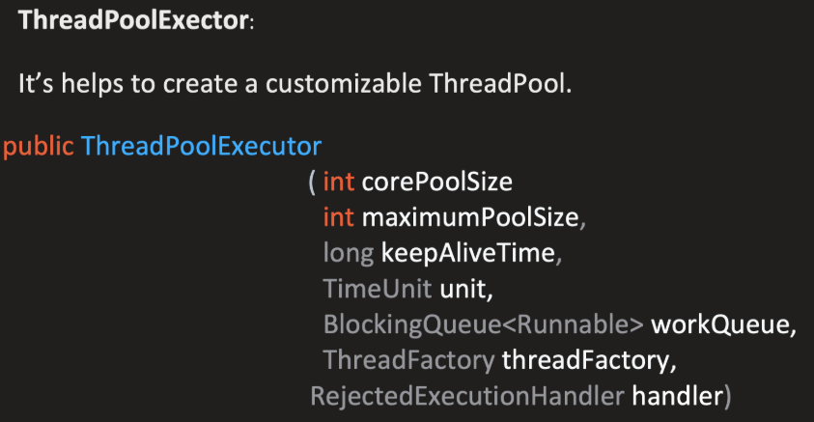

If task9 comes and it is not finding any free thread in TP, and it is not finding any space in queue, then Executor framework will see that maximum thread is 5 and only 3 threads has been used then it’ll create 1 more thread T4 which will be assigned task9.

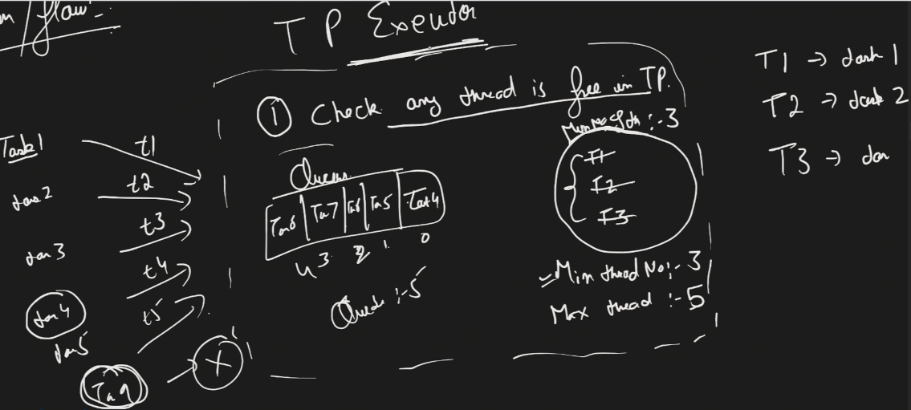

If task10 comes then it see no free thread in TP and queue is full but no of threads 4 < max threads count 5 so T5 is created and assigned task10.

Now if task11 comes the it will be rejected.

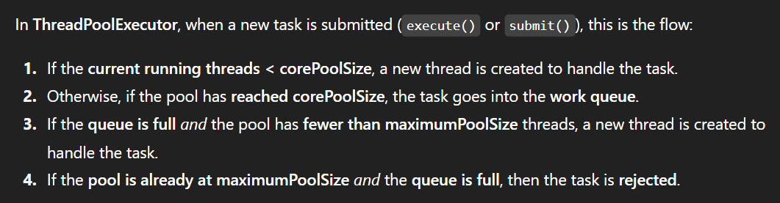

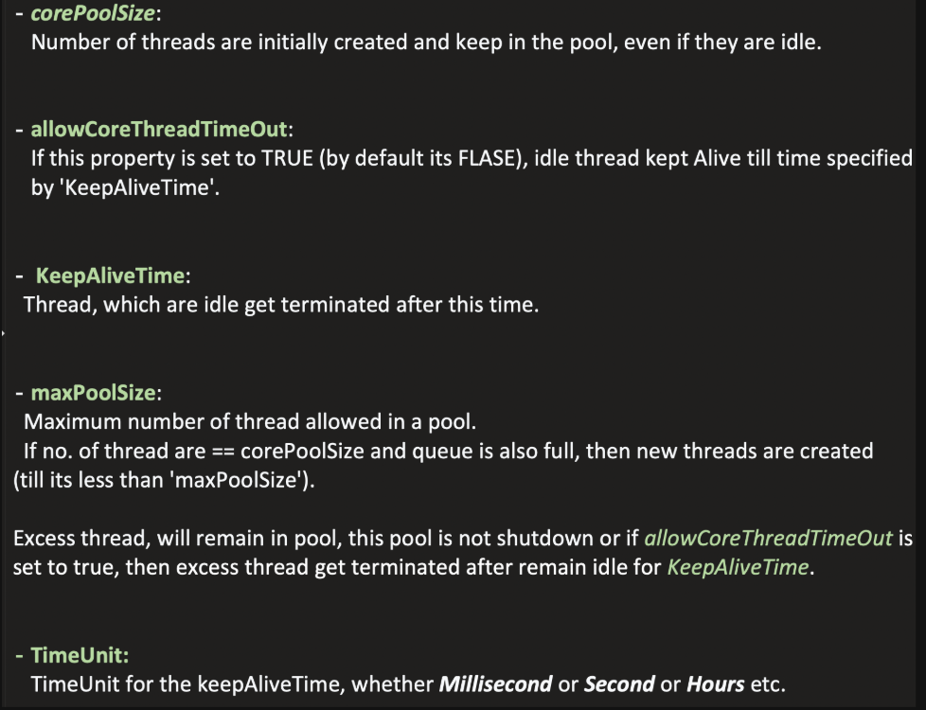

**corePoolSize** is the minimum number of threads to keep in the pool, even if they are idle.

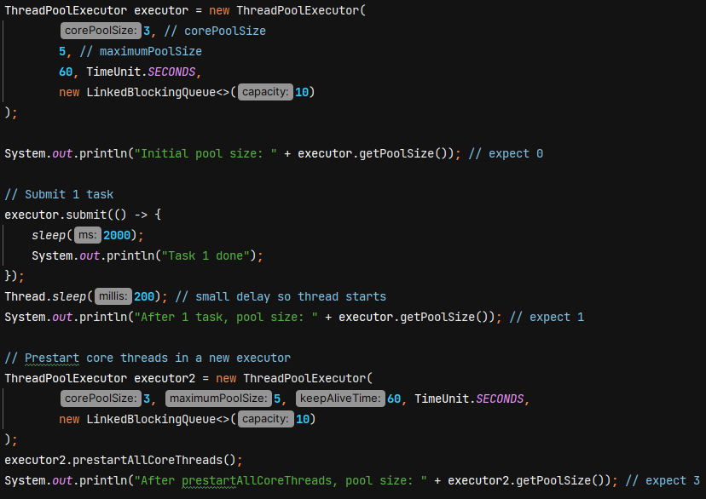

ThreadPoolExecutor will create threads on its own, it will give thread name, priority, thread daemon value on its own. But if you want to override that property you can provide ur own **ThreadFactory.**

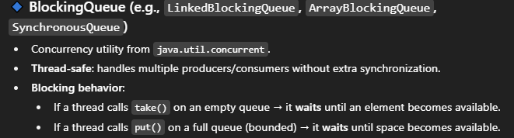

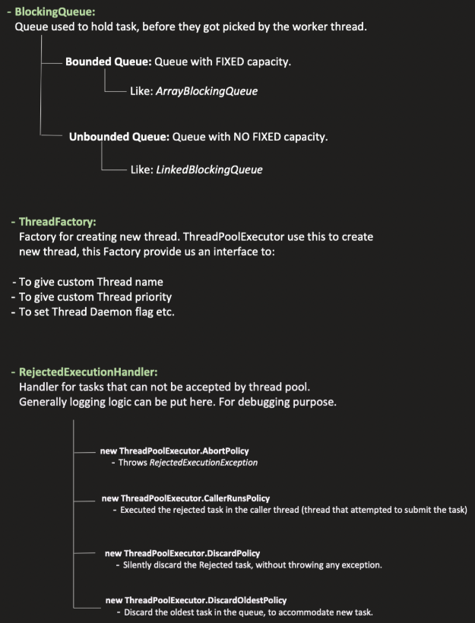

Why we don’t create thousands of threads in java –

1. **Memory Cost per Thread** - Each thread gets its own **stack memory** (default ~1 MB on many JVMs). If you create 10,000 threads → that’s ~10 GB just for stacks! (before even doing real work).
2. CPU Scheduling Overhead - OS uses **context switching** to give CPU time to threads. If you have way more threads than CPU cores, the OS spends most of its time **switching threads** instead of doing real work so kill performance.
3. More threads = more chances they compete for: Locks & Shared data structures (heap objects, DB connections, etc.) This increases **blocking time** and reduces throughput.

**Factors to consider before deciding min and max threads in ThreadPool** –

**CPU intensive task** means they want more CPU/processing time like image processing, encryption, ML tasks etc. **Less thread must be there.**

**I/O intensive task** means u want o make some DB call so thread is idle during DB call. So if a thread is idle its better to have more threads so CPU doesn’t wait, it can context switch the waiting thread and by the time CPU can process some other thread. **More thread we should be keeping**.

I/O-bound tasks spend most of their time waiting for input/output operations to complete. During this waiting period, the thread is typically paused, or **blocked**, until the external resource responds. This is generally considered bad practice in highly concurrent server environments for several critical reasons –

* **Thread Starvation –** If you have a pool of 200 threads, and 199 are blocked waiting for slow database responses or external APIs, only 1 thread is available to handle a new incoming user request. New requests will pile up in a queue. If the queue fills up, the server might start rejecting connections, leading to severe performance issues or outages.
* **Resource Overhead** – While a blocked thread isn't using the *CPU*, it still consumes memory and other operating system resources (a stack, thread-local storage, etc.)

**Memory Required to process a request –** suppose a POST request comes which stores soo many data from DB, service calls into heap memory and heap also has limited space. Suppose if each request takes 10 MB and I accepted 100 requests so do u have sufficient memory in heap?

**Throughput –** how fast you can process the request.

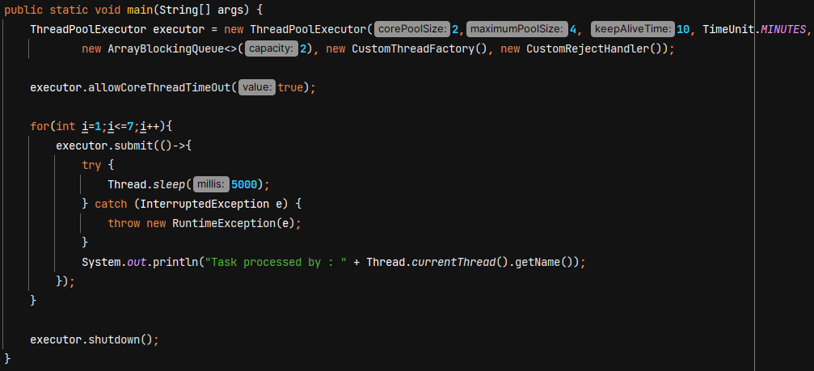

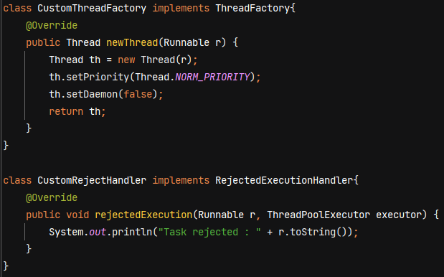

Using **Runtime.getRuntime().availableProcessors()** you can get the no of cores on your machine.

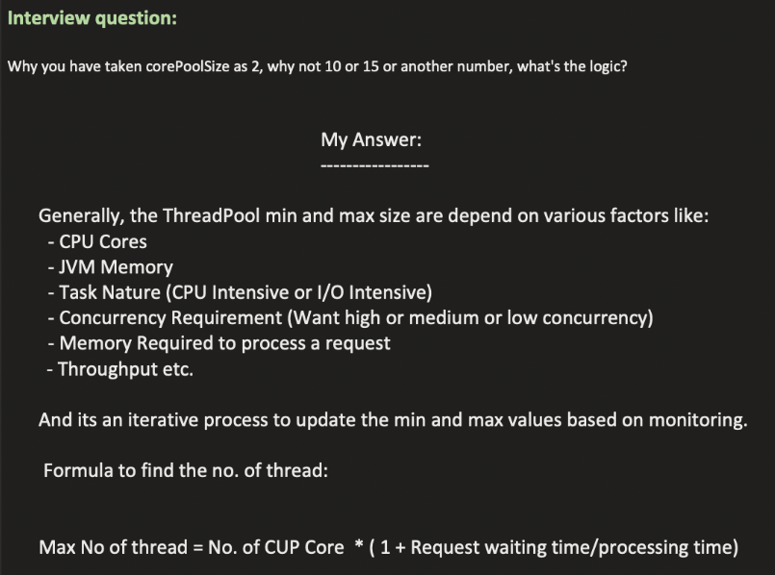

The above formula basically consider CPU core & Task Nature for giving no of threads.

For CPU intensive – request waiting time is very less and processing time is more

For I/O intensive – request waiting time is more and processing time is less.

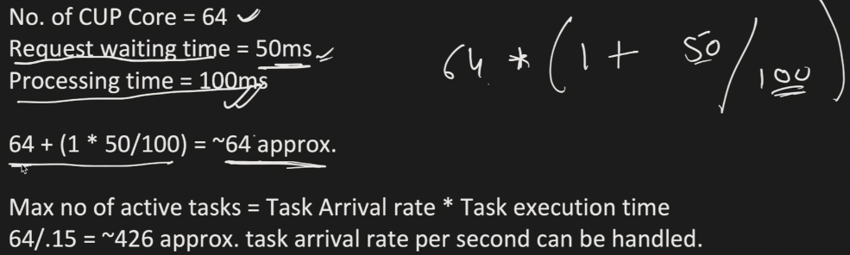

**But this formula does not consider the memory -**

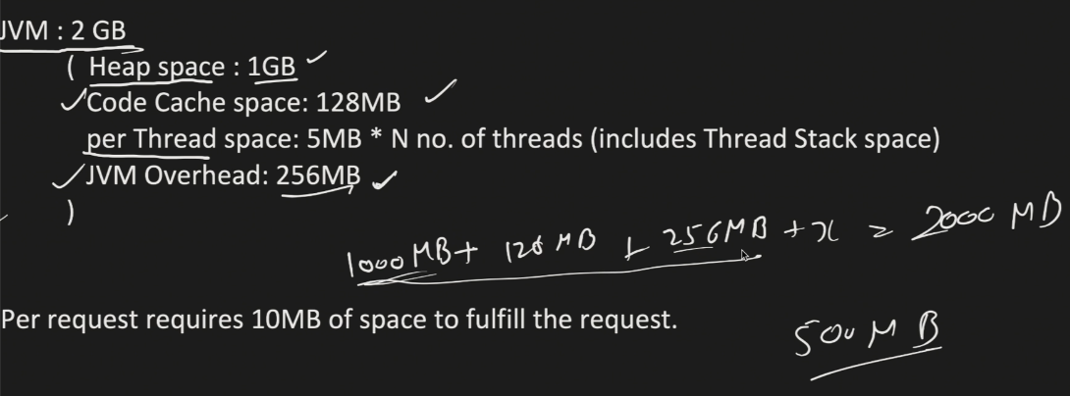

Out of this remaining 500MB we can accommodate for Threads. For each thread we need to create stack, register, etc.

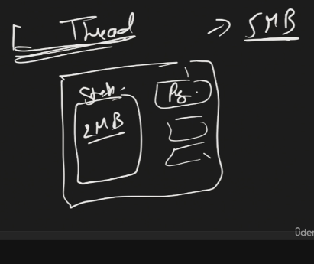 If 1 thread takes 5MB then we can create maximum 500/5 = 100 Threads

**Now consider Memory required to process a request –**

Suppose 1 requests takes 10MB becoz it has to load data from DB, from external calls and this data will be stores in Heap. If 100 Threads are created then 100 * 10 = 1000MB (~1GB) then this will full the heap that is risky again. So we can say lets put some buffer and use 60% or 70% of heap because we might need heap for some other tasks also.

So lets create 60 Threads. 60 * 10 = 600MB this much heap will be used by threads. Its safe number.

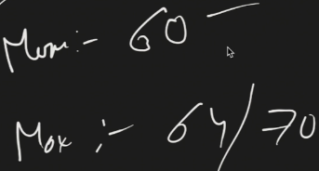 Now I have to monitoring, iterative load & performance testing and optimize this number.

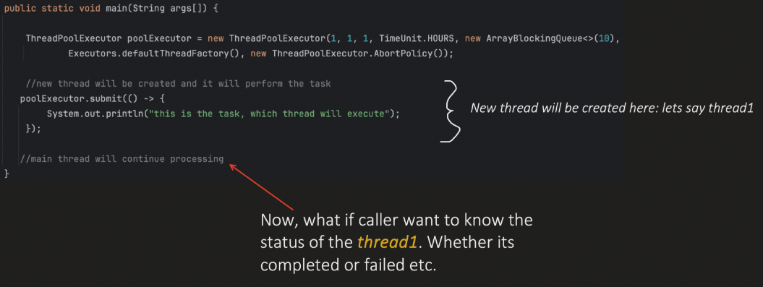

So we can create a Future object and hold the reference, using that we can know the status of task.

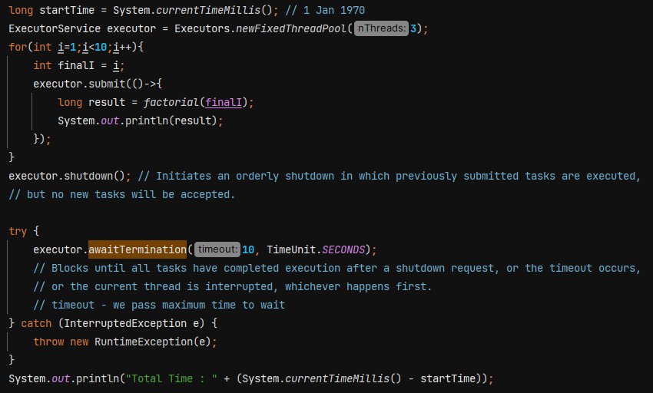

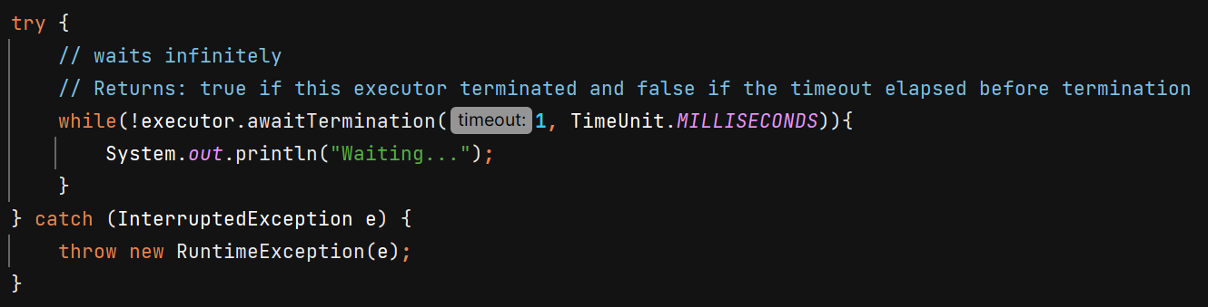

**submit()** 🡺 it accepts any number of tasks. The task is queued and will execute automatically if a thread from the pool is available.

**shutdown()** 🡺 Gracefully shut down the executor service. It does not block the current thread.

**shutdownNow()** 🡺 Forcefully stops all running/waiting tasks.

**awaitTermination()** 🡺 Blocks current thread and Returns true if this executor terminated and false if the timeout elapsed before termination. It is called after shutdown() ExecutorService.

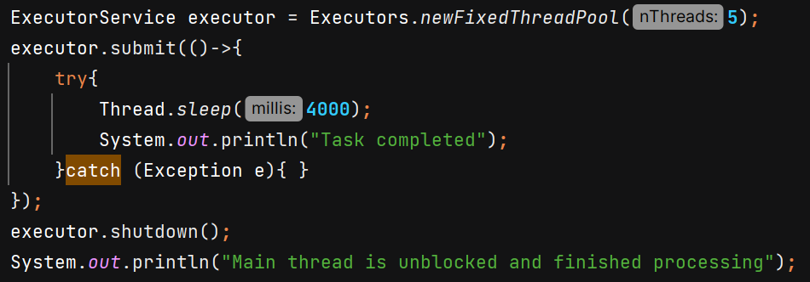

O/P - 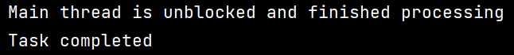



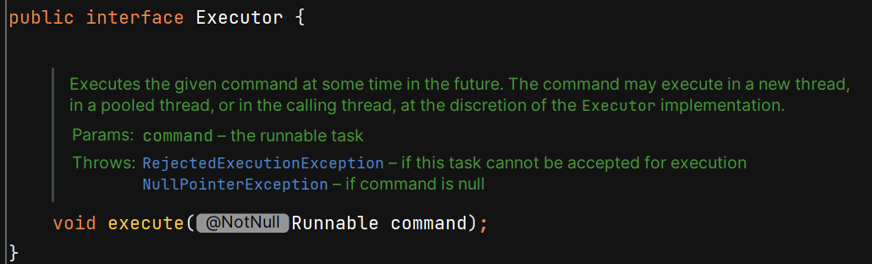

Executor does not contain methods like shutdown() so u need to manually do it. That’s why its useless. We’ll use ExecutorService becoz it provides more features.

**Submit()** method returns **Future<T>** which represents the result of an asynchronous task.

future**.get()** blocks the current thread until task completed, or thread interrupt or execption thrown.

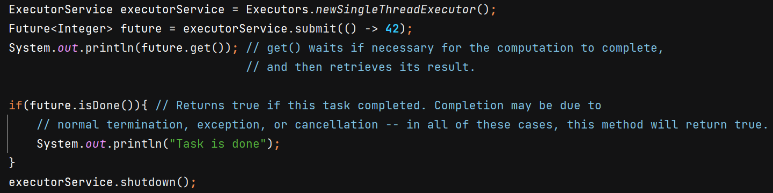

O/P - 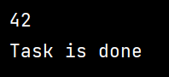

Submit() can take Runnable as well as Callable – 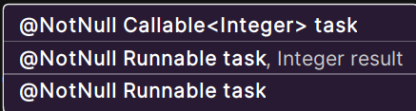

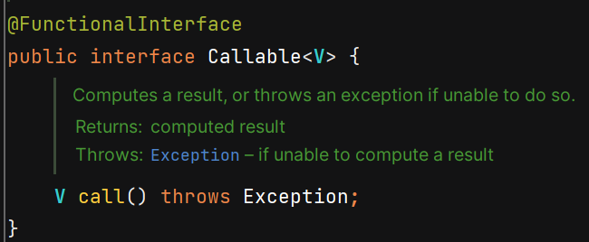 Callable returns value.

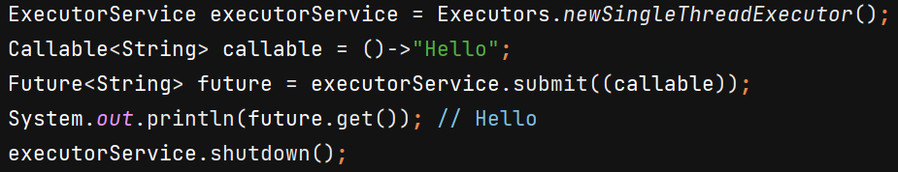

submit() method of Runnable argument is called -

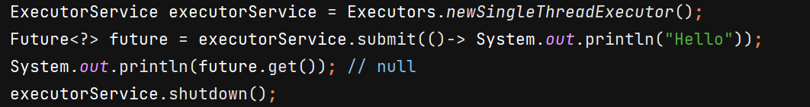

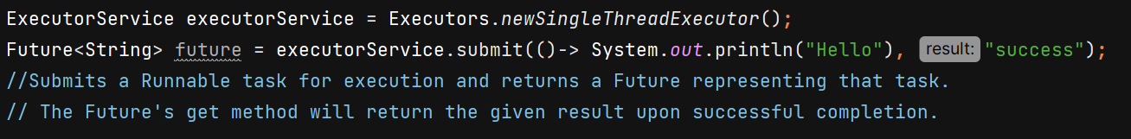

Difference - 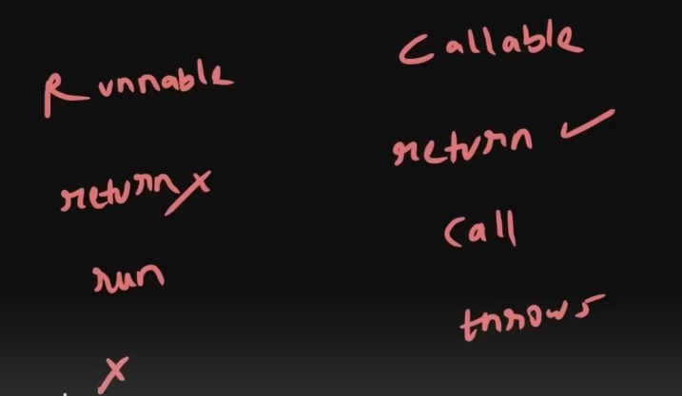

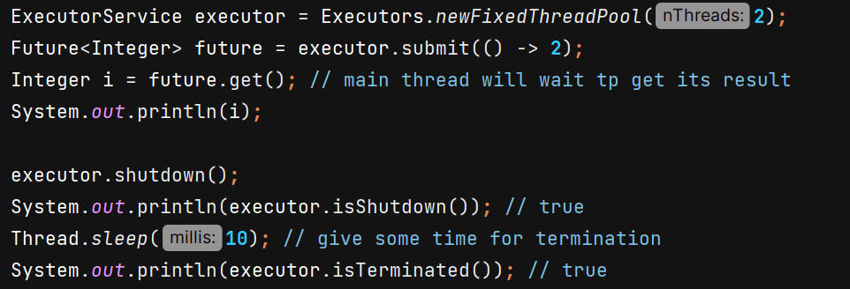

If tasks are **still running**, but shutdown() has already been called → isShutdown() returns true.

**isTerminated()** 🡺 return true if all tasks have completed after shut down

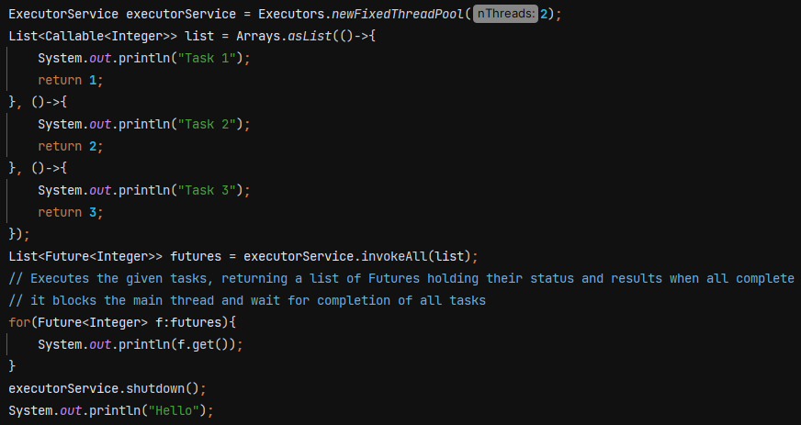 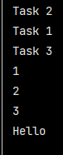

**invokeAll()** 🡺 It **submits all tasks** and then **waits (blocks)** until **all of them finish**.

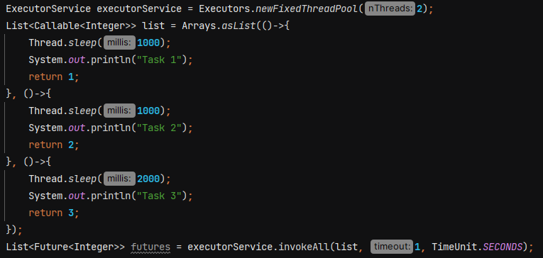 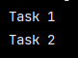

When we pass timeout in constructor, then it executes all the task which can be executed within time frame and other tasks are cancelled.

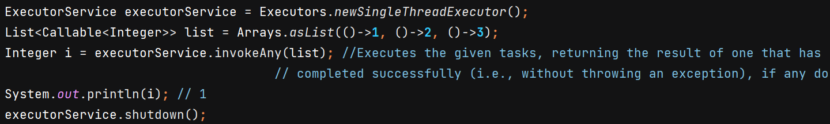

**invokeAny() also blocks the current thread.**

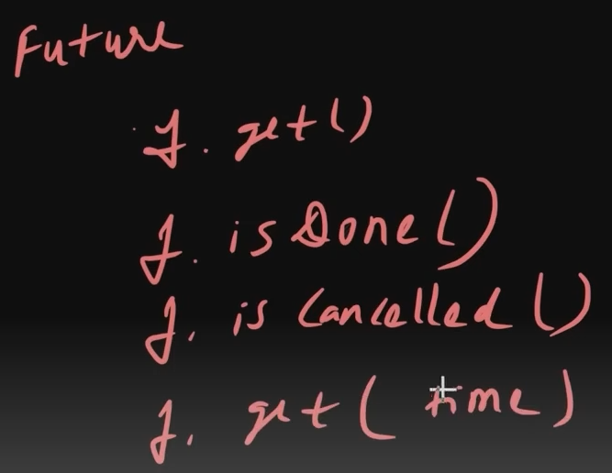

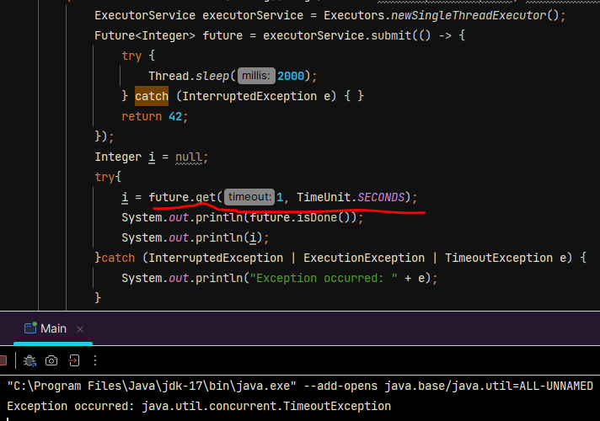

Explaination :- It waits for 1 sec, if task get completed then fine otherwise it gives TimeoutException.

**isDone()** 🡺 Returns true if this task completed. Completion may be due to normal termination, an exception, or cancellation.

**cancel()** 🡺 If the task has already completed it cannot be cancelled and .**cancel()** returns false.

* If task is still running it can be cancelled and **.cancel()** returns true.
* mayInterruptIfRunning parameter determines whether to run the complete task or not.
* Future will not return any value and we get **CancellationException** if we use **.get()**

**isCancelled()** 🡺 Returns true if this task was cancelled before it completed normally.

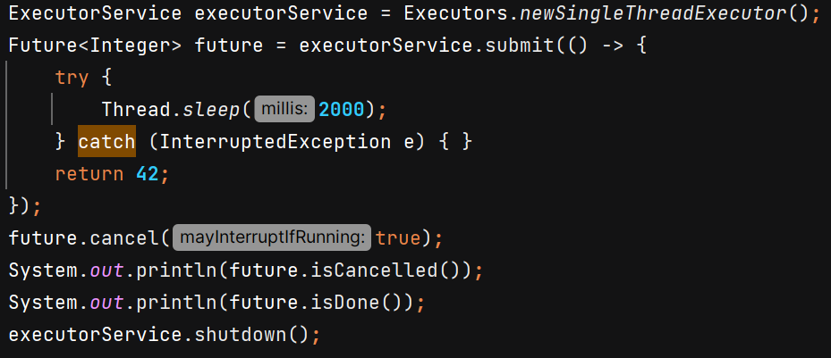 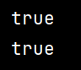

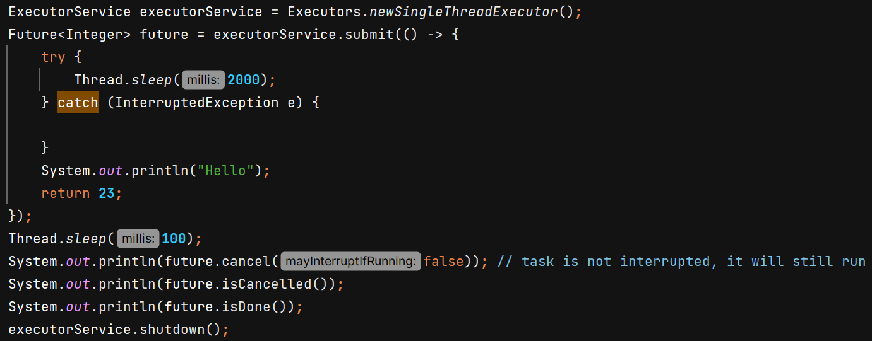 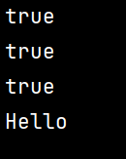

**Scheduled Executor Service** – used when we want something to run periodically / helps to schedule tasks.



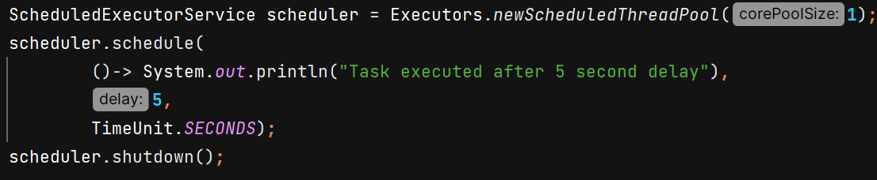

O/P 🡪 

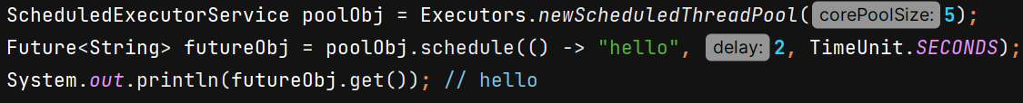

.**schedule() 🡪**  *Submits a one-shot task(runnable/callable) that becomes enabled after the given delay*

.**scheduleAtFixedRate()** 🡪 Submits a periodic task that becomes enabled first after the given initial delay, and subsequently with the given period; that is, executions will commence after initialDelay, then initialDelay + period, then initialDelay + 2 * period, and so on.

If scheduler.shutdown() is called **before the initial delay expires**, the scheduler will terminate immediately, and the task will never run. So we need to handle it properly –

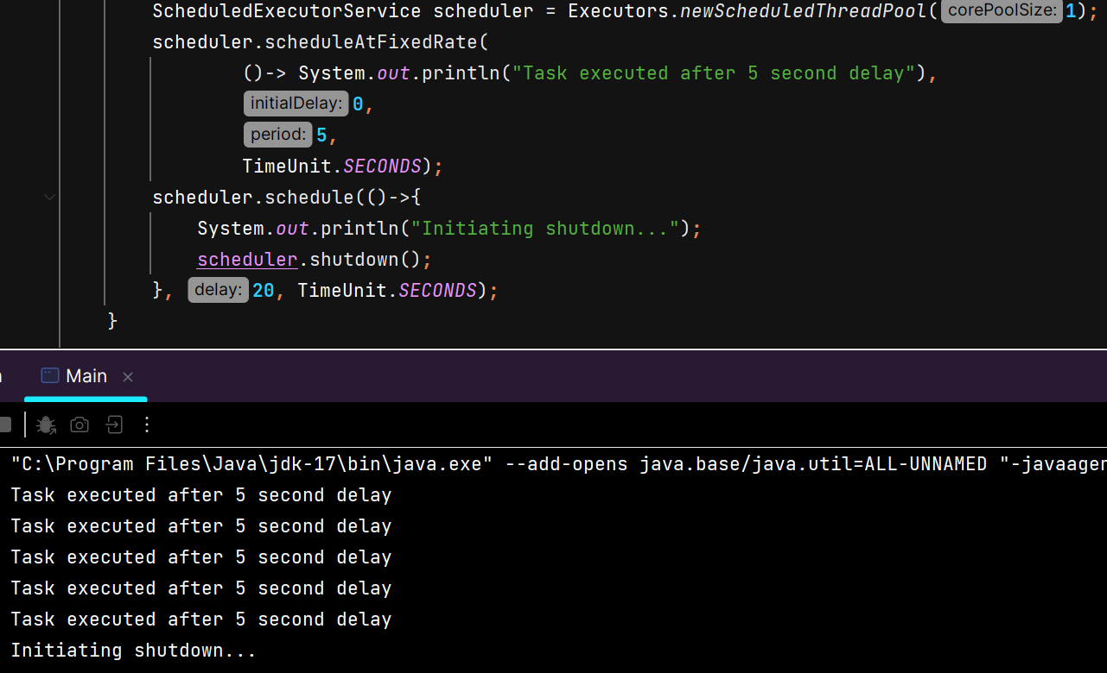

O/P 🡪 

If previous task is still waiting and next task is scheduled, then it will wait in queue for completion of previous task and as soon as it completes, next task also starts executing.

**scheduleWithFixedDelay()** 🡺 Submits a periodic action that becomes enabled first after the given initial delay, and subsequently with the given delay between the termination of one execution and the commencement of the next.

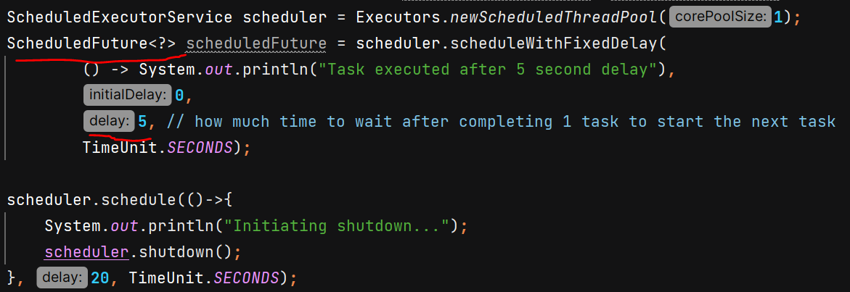

O/P 🡪 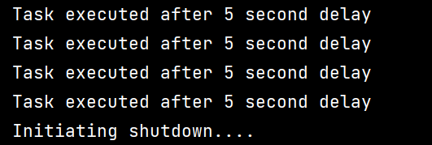

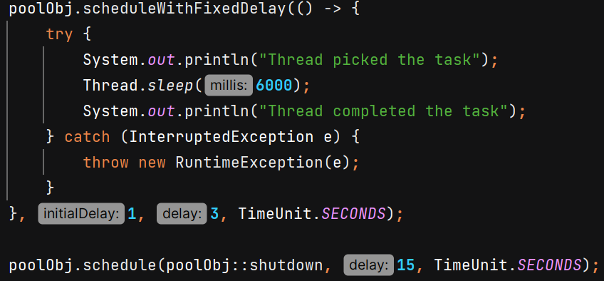 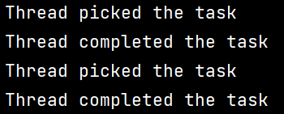

With fixed delay, after “Thread completed the task” next sout statement “Thread picked the task” comes after 3 seconds.

If I use at fixed rate, then after “Thread completed the task” next sout statement “Thread picked the task” will come immediately becoz task is already scheduled and waiting in queue for previous task to be finished.

**Cached Thread Pool –** It creates a thread pool where it creates new threads as per need and terminates them after 60 seconds of inactivity. It dynamically adjusts the pool size. It is useful when load is variable and short lived. Do not use it when task are very time consuming.



**CompletableFuture**

Introduced in JAVA 8 to handle asynchronous programming.

It **implements Future** interface so has all its method and provides additional capability like chaining.

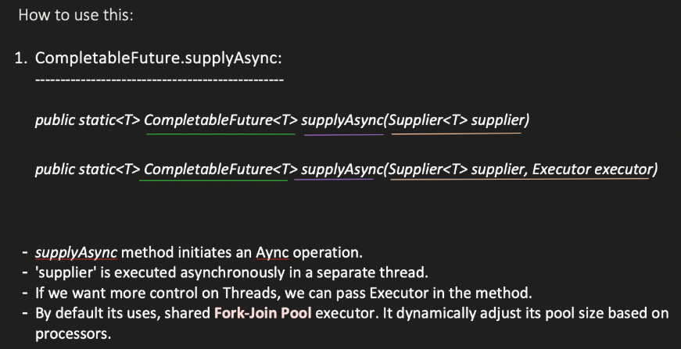

Default parallelism of ForkJoinPool.commonPool() = **max(1, availableProcessors − 1)**

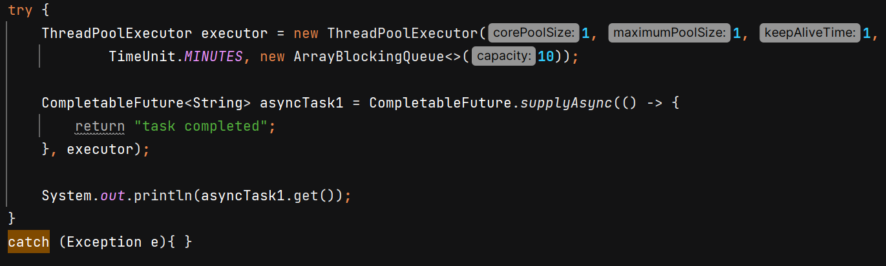

O/P - 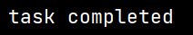

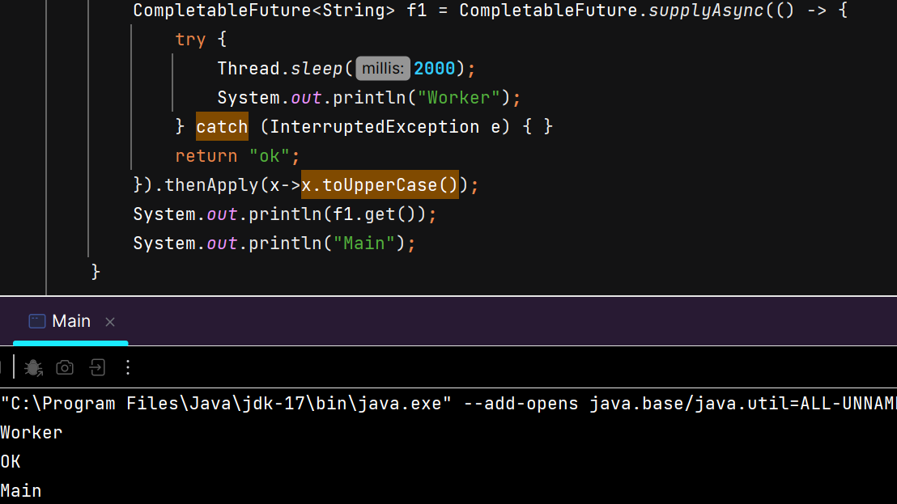 

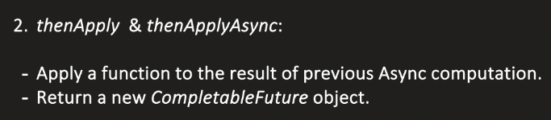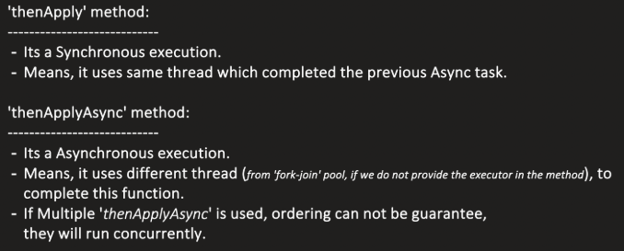

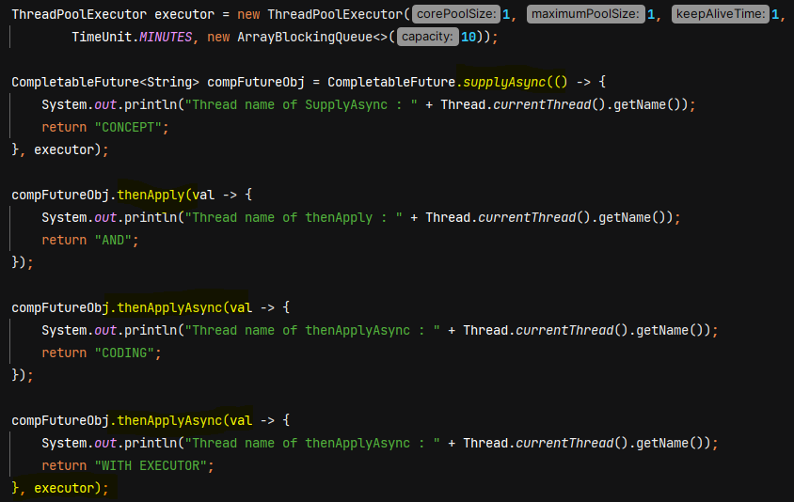

O/P - 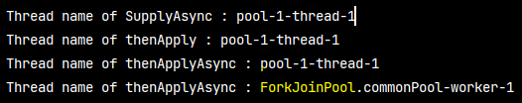

If we don’t provide executor in thenApplyAsync then ForkJoinPool.commonPool() will be used.

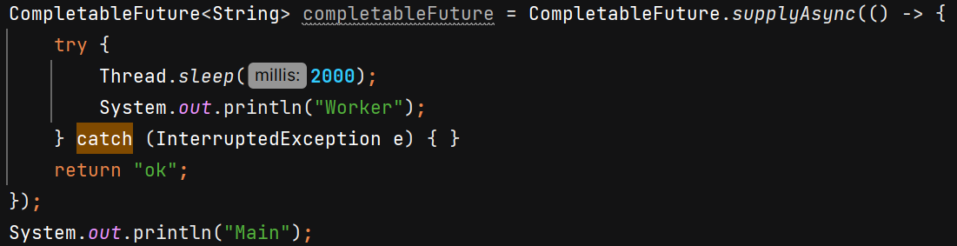 O/P – 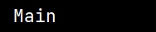

we don’t see sout of “Worker” because by default, CompletableFuture.supplyAsync() uses the **ForkJoinPool.commonPool()**, and the threads in this pool are **daemon threads**.

If we want to run the task –

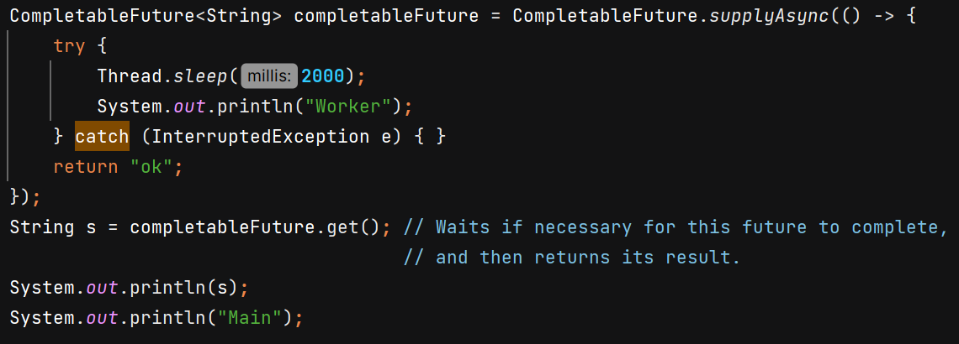 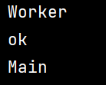

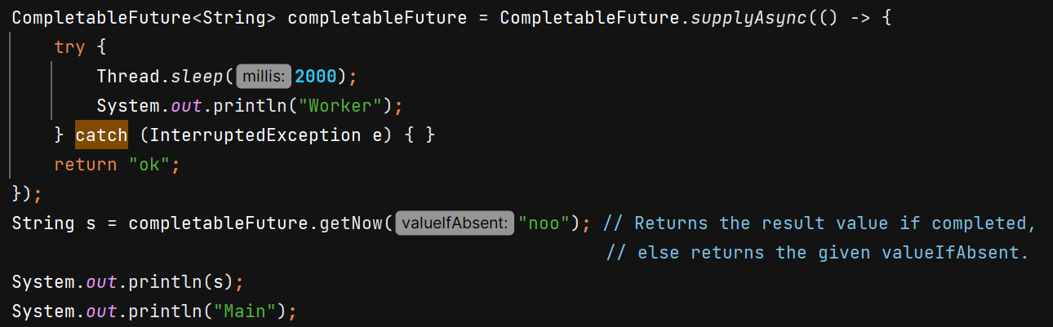 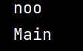

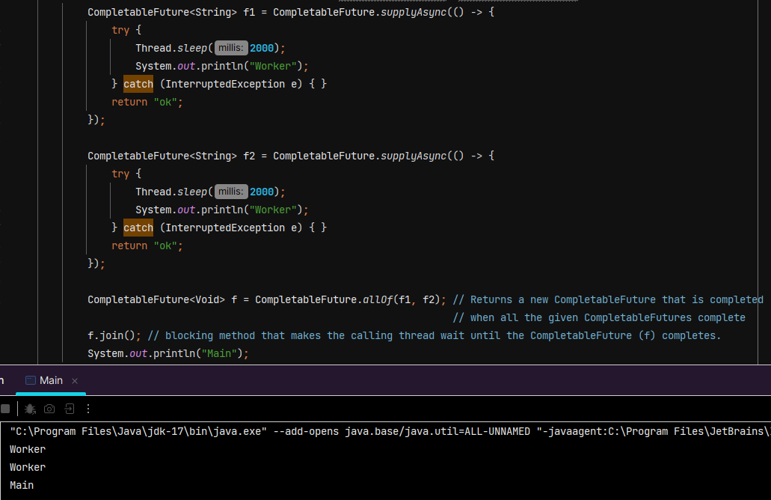 

We can also use join() with CompletableFuture instead of get().

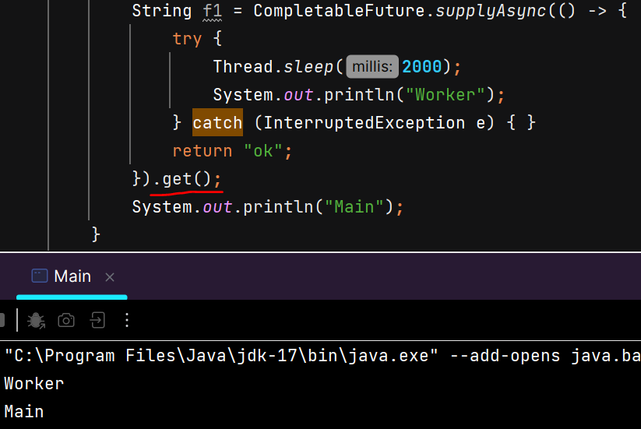 

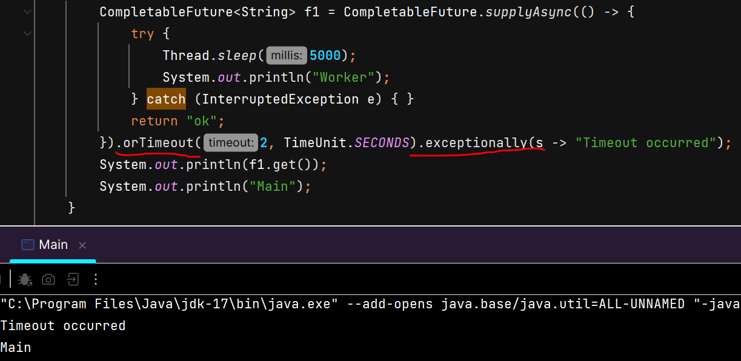 

**Note**: Use CompletableFuture without a custom executor only for CPU-bound work.  
For any I/O-bound or blocking operation (HTTP calls, DB queries, file I/O), always provide a custom thread pool executor.

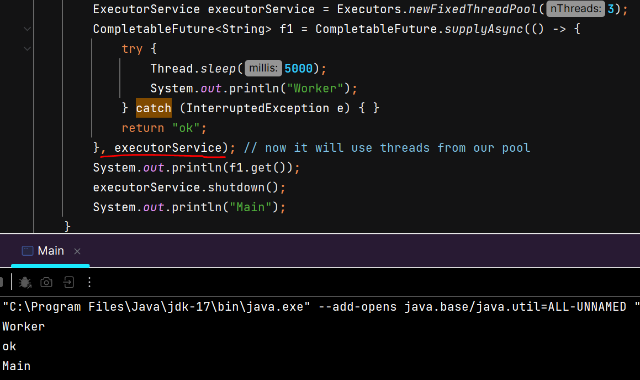 

shutdown() is necessary when using custom executor.

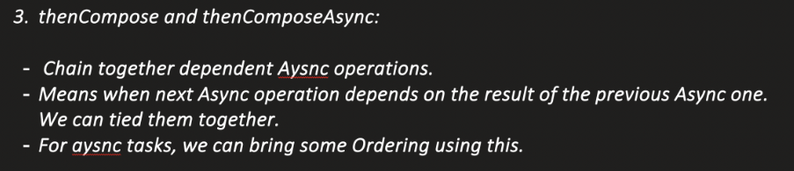

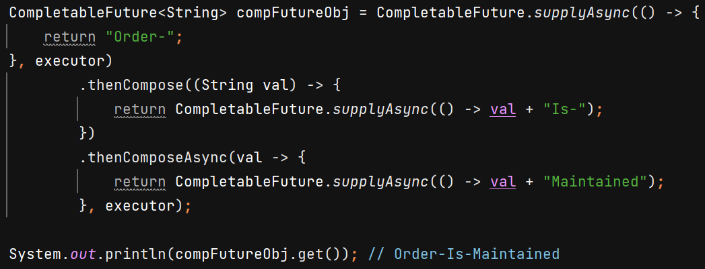

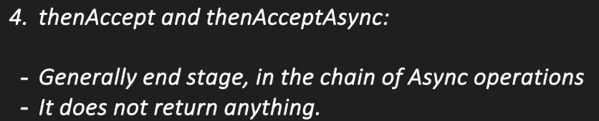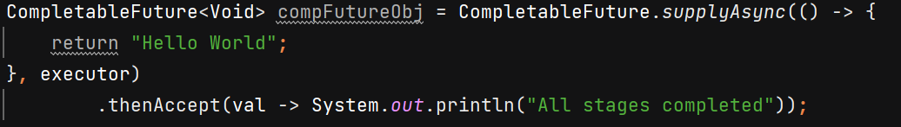 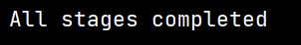

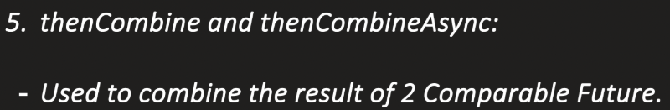

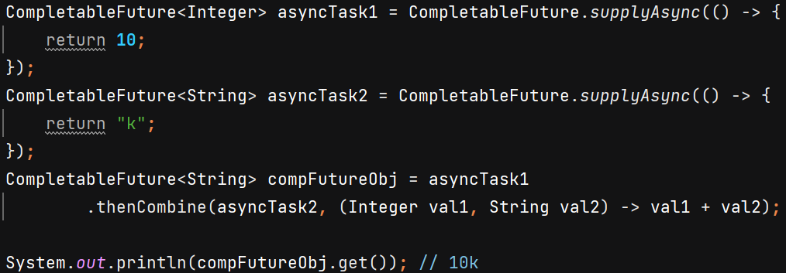

**6) runAsync()** – used when we pass runnable and no result needs to be returned

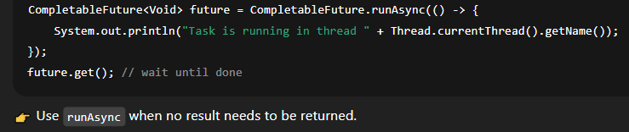

**Executors** provices Factory methods which we can use to create Thread Pool Executor.

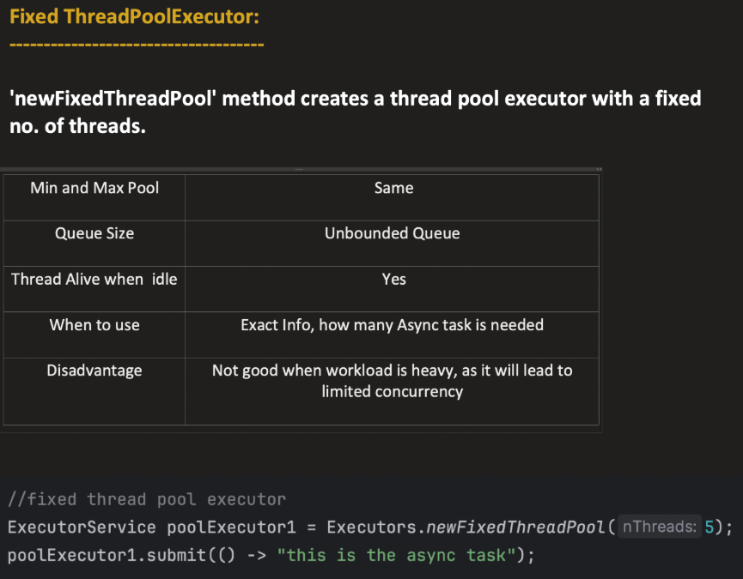

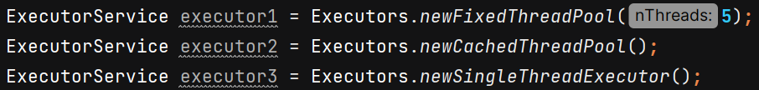

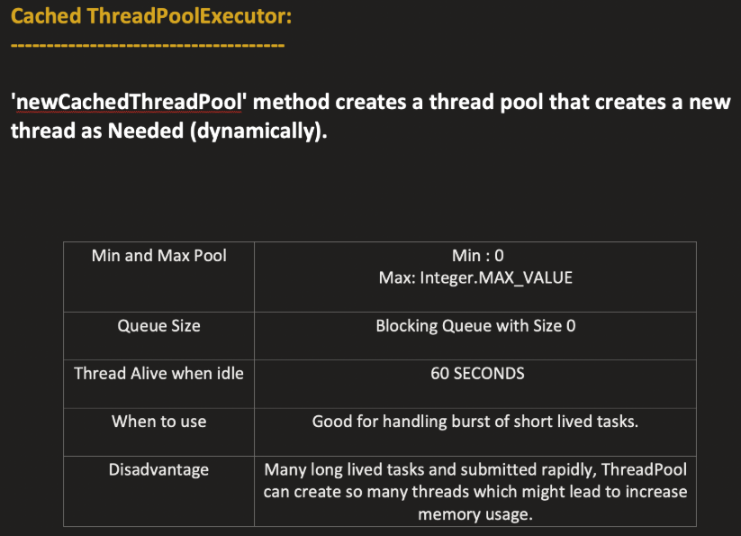

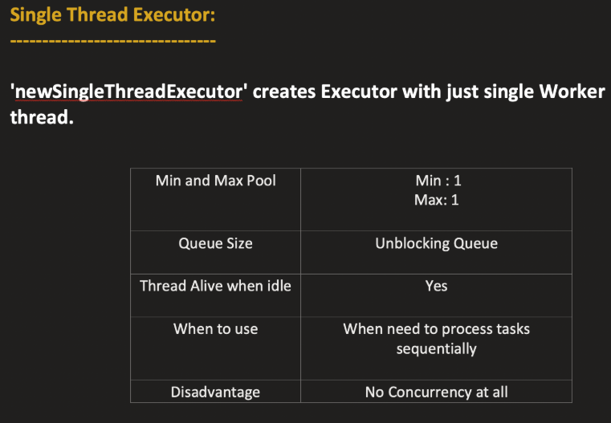

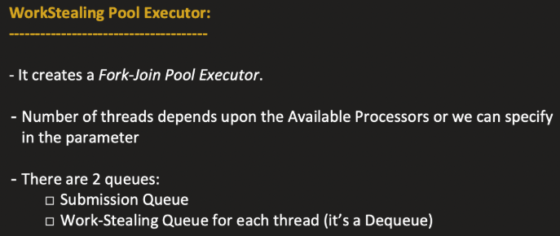

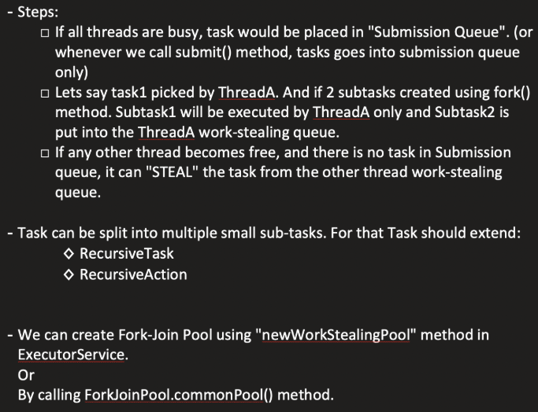

We can divide bigger task into smaller using fork() and then wait for them to complete using join() and ultimately return the final result.

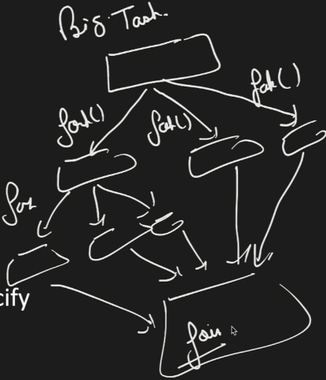

The purpose is to bring more parallelism by dividing bigger task so multiple threads can execute each subtask.

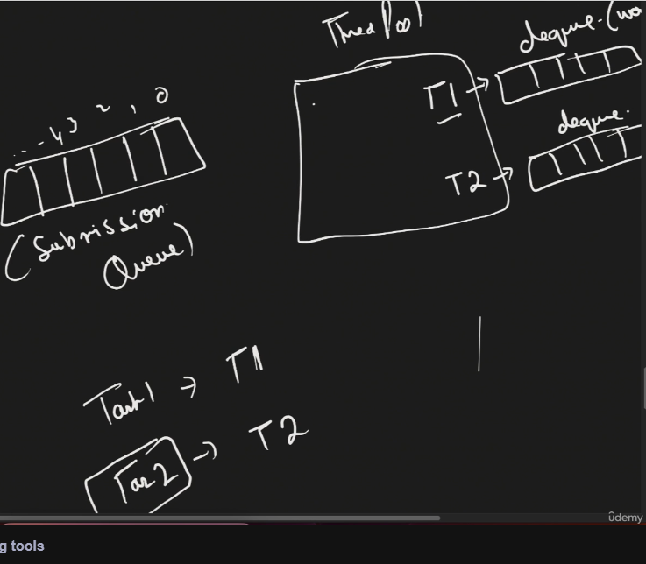 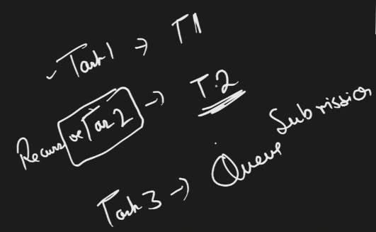

In WorkStealing pool, each thread maintains its own dequeue (work-stealing queue). Suppose Task1 comes its picked by T1. Task2 comes, it can be divided into subtasks and T2 picks it. T3 comes, it is put into Submission queue.

Suppose T2 divides task2 into subtask1 and subtask2, then T2 will start working on subtask1 and put subtask1 in its work-stealing queue.

Suppose T1 completes Task1 and its free, so next **it will first check its work-stealing queue if any subtask present? Then its will check its submission queue.**

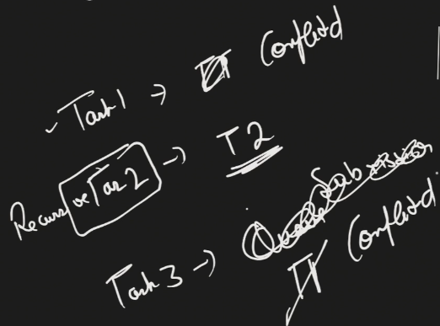

T1 picks Task3 from Submission queue and complete it. T2 is still busy with subtask1 of Task2.

Now T1 will again see –

1. Check its work stealing queue if any subtask present?
2. Check submission queue if any task present?
3. Can I steal a subtask from busy thread’s work-stealing queue

So T1 will steal the substask2 of Task2 from workstealling queue of T2 and put that subtask in its work work stealing queue.

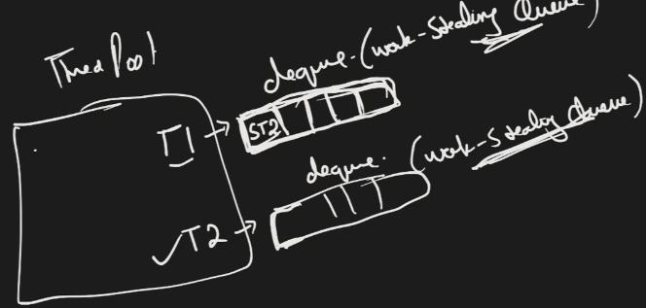 Since T1 is free so it will pick subtask2 of task2 and start working on it. It uses dequeue becoz whenever any thread try to steal subtasks, it will steal it from back and thread T2 will consume its subtasks from front.

Whenever ur subtask need to return anything 🡪 go for **RecursiveTask**

Whenever it does not return any value 🡪 **RecursiveAction**

Ex- Task is to compute sum from start to end.

Whenever u do fork(), means u are dividing the task into multiple subtasks, in which 1 subtask the same thread is gonna pick and put other subtasks into its work-stealling queue which can be steal by some other thread which is free.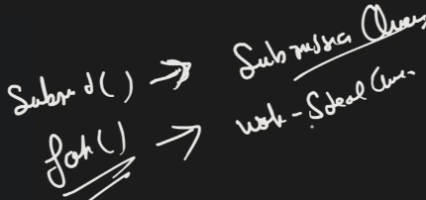

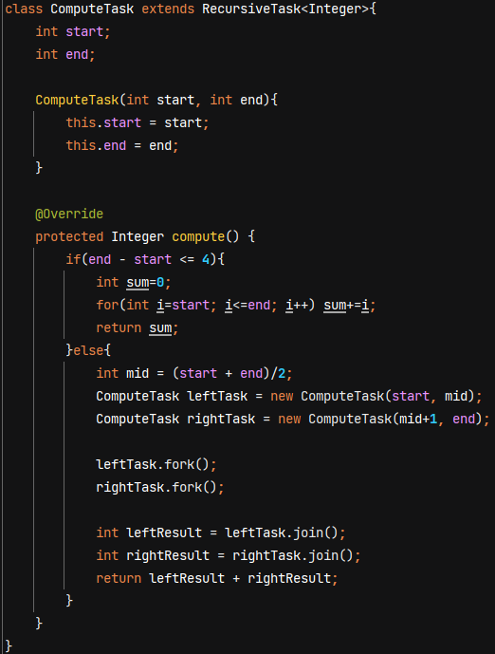

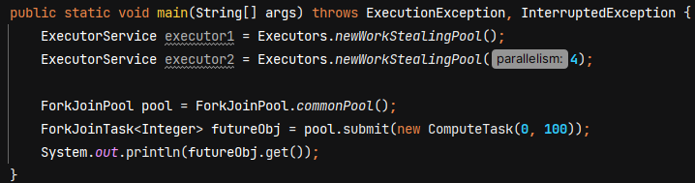

**ThreadLocal**

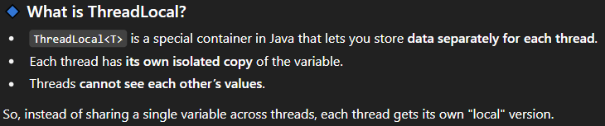

Each thread has a ThreadLocalMap object and when we set() in ThreadLocal variable it first fetch the ThreadLocalMap of that thread and set value inside it.

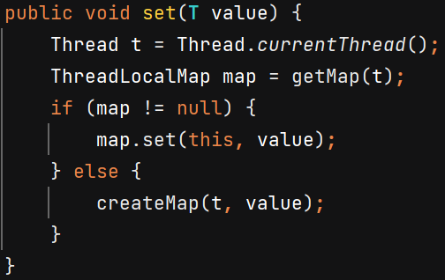

When we call get() then it fetch data from current thread ThreadLocalMap.

When u call remove() then for that particular thread, it will clear the ThreadLocal variable.

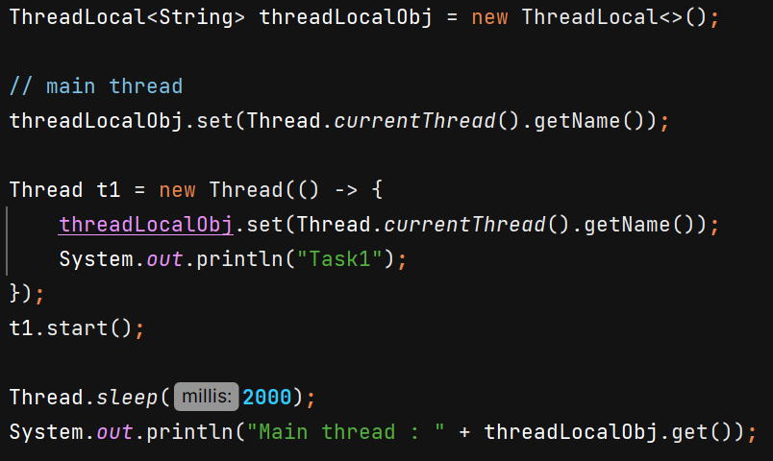 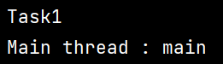

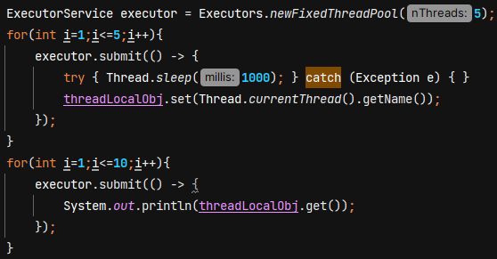 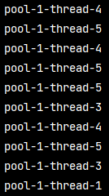

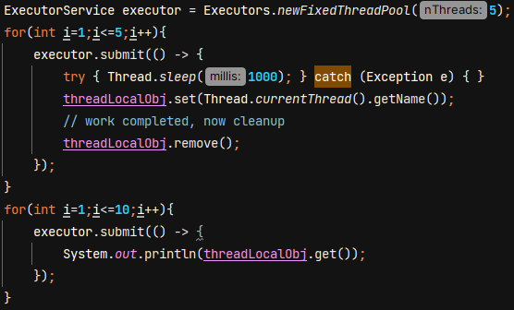 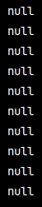

**Virtual Thread** 🡪 Lightweight threads introduced to get higher throughput. Ideal for I/O bound tasks. We can create thousands of virtual threads.

Throughput – in 1 second how many tasks/requests can you perform.

Latency – time taken for a single request to travel from start to finish. Its like the delay u experience when u ask system to do something.

Platform thread (what Java calls Thread) is managed by JVM which is like wrapper around native/OS thread. So if you are creating 10 threads, then those 10 threads are 1-1 mapped with OS threads.

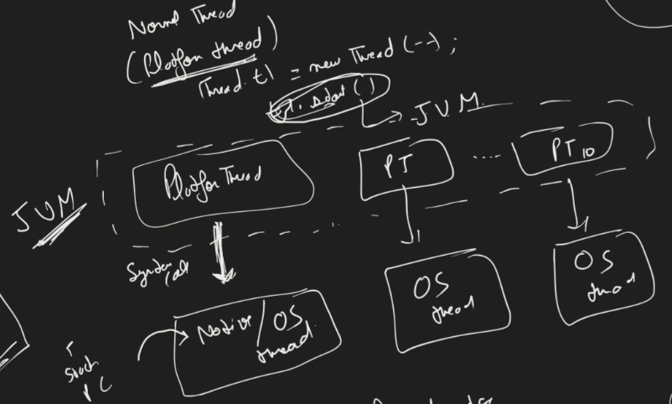

Disadvantage –

1. Its slow becoz thread creation takes time. When u call th1.start() u r trying to create one thread and java calls OS to create 1 native/OS thread. This is a system call and it takes time.
2. Suppose ur thread is waiting for certain DB call which takes 4 sec. So ur thread is in waiting state and due to 1-1 maping the OS thread is also waiting. 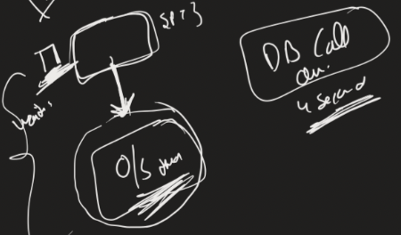

**WORKING 🡪** If any virtual thread which wants to execute and not in waiting state, then only it would be attached to OS thread. And if it wants to go into waiting state, then JVM will detach the link between OS thread and virtual thread. And any other virtual thread which wants to run that linking would be done.

So there is no 1-1 mapping between virtual thread and OS thread. Apart from this all the functionalites are backward compatible and we can apply all multithreading concepts. Only difference is how JVM is managing the thread.

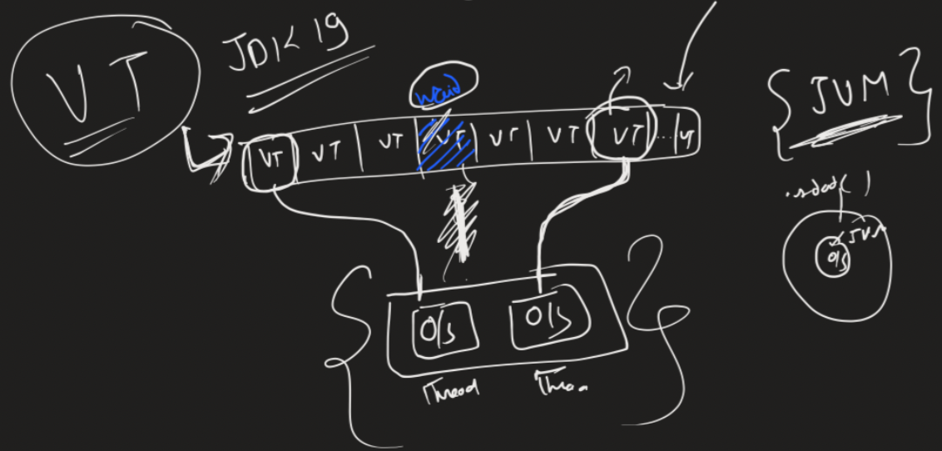

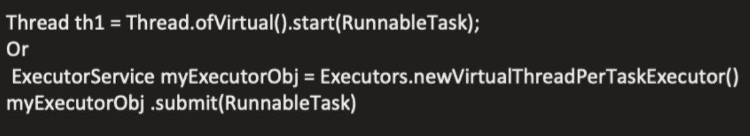

**Volatile vs Atomic**

Volatile 🡪 Always **read and write should happen directly to main memory**.

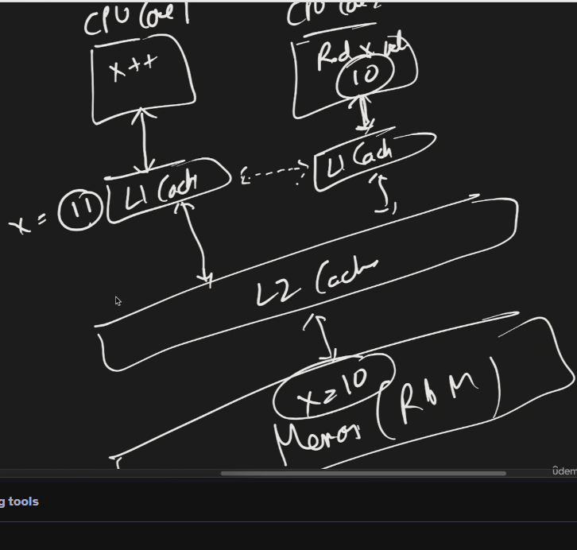 Suppose t1 running on CPU core1 increments x, it first get updated in L1 cache.

This is generally structure of CPU, L1 cache stores the data and periodically all L1 caches of different cores get sync up with each other.

If T2 running on different CPU core try to read x from its L1 cache and value not present because sync up did not happen, then it check L2 cache, value not present and then read x=10 from RAM

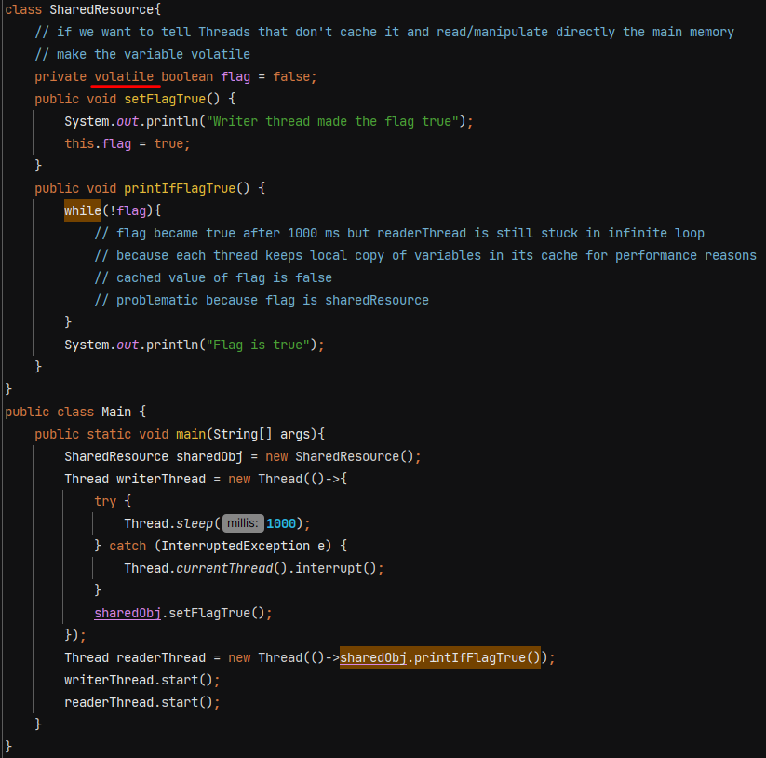

**Note: -  All fields being read in a synchronized block will be read from main memory.**

If we don’t make variable volatile then readerThread is stuck in infinite loop. But in complex scenarios it also has disadvantages as there is no thread safety.

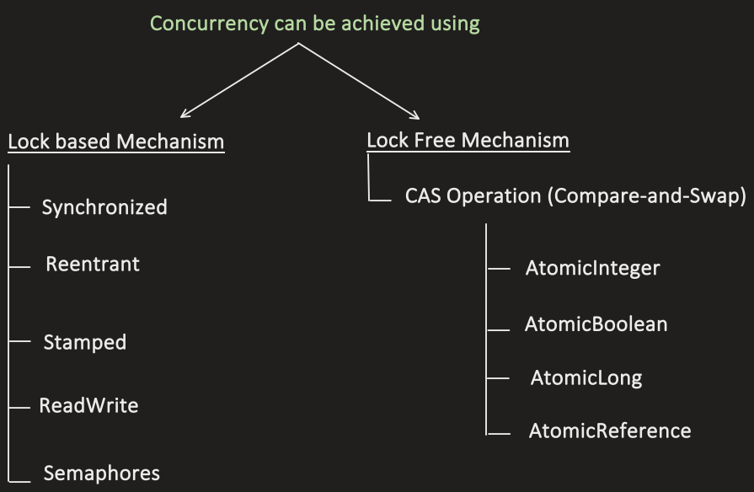

Concurrency can be achieved using **Lock Free Mechanism (Compare And Swap)** which is faster but its usecase is very specific. It is not alternative to Lock based mechanism.

Optimistic concurrency control is inspired by CAS but its mostly used in DB operations whereas CAS used in low level cpu operations.

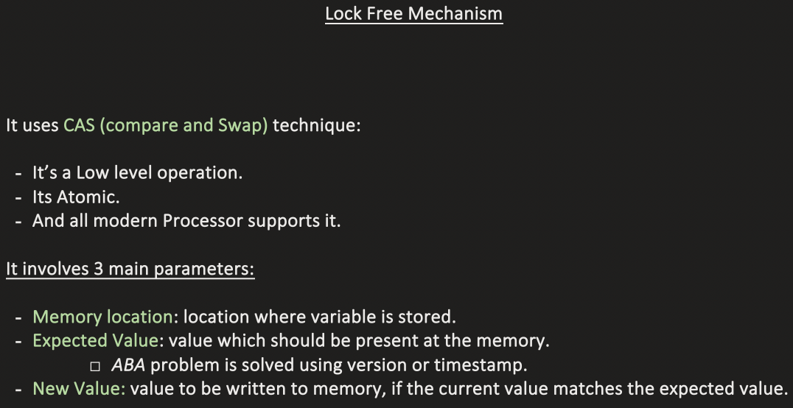

**Atomic** :- 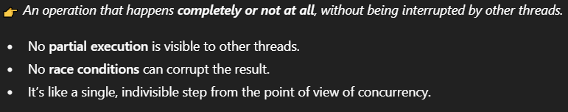

AtomicInteger, AtomicLong, AtomicBoolean - does not use locks. It achieves thread safety using **non-blocking, lock-free algorithm CAS** that rely on **low-level hardware support** for atomic operations.

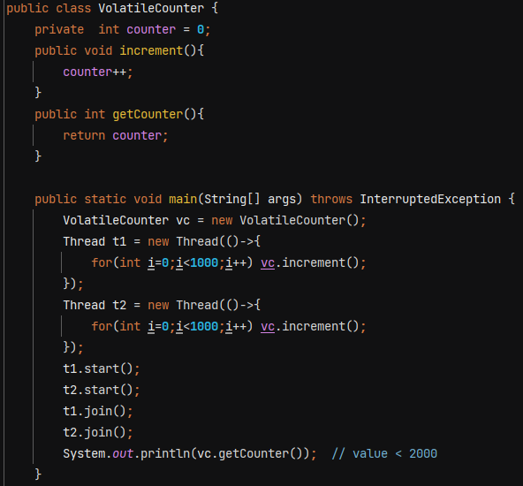

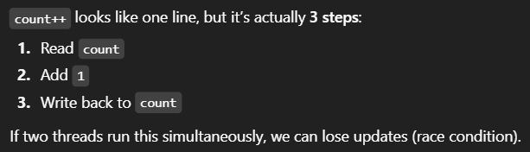

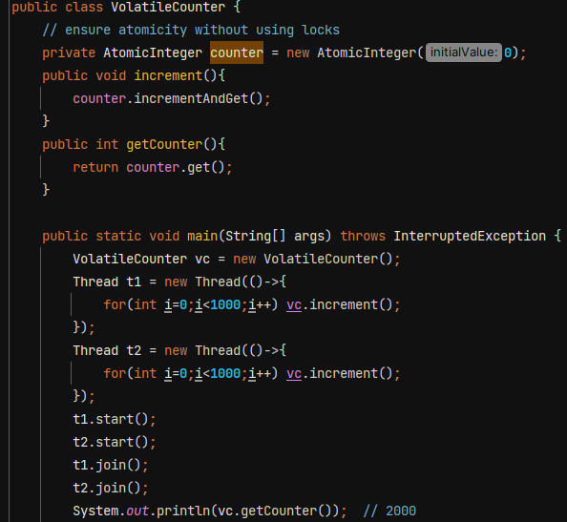

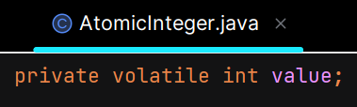 value is read directly from main memory during CAS operation.

Volatile has no relation with concurrency. It is not thread-safe.

Inside **incrementAndGet()** method we do something like this -

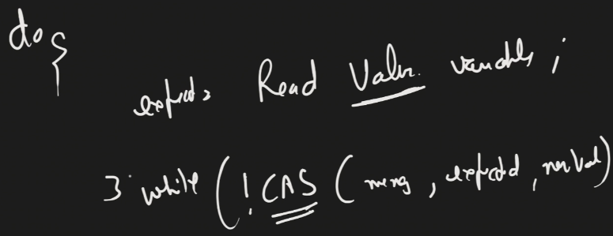

Till CAS operation is not success, thread will continue to try. CPU ensures CAS is atomic and only 1 threads can perform it on the same memory location.

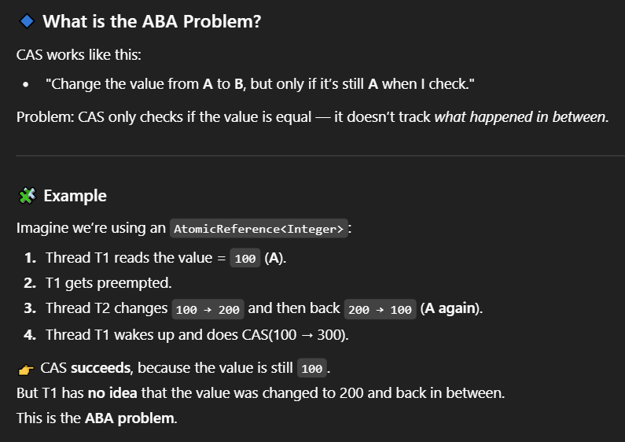

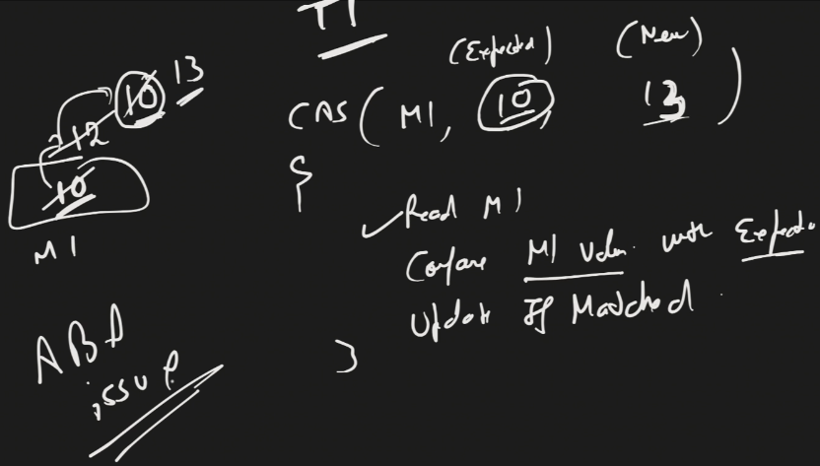

This problem is solved by using stamp/version with value –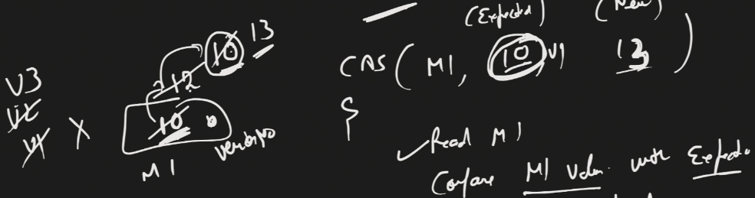

V1 != V3 so value does not get updated.

Java provides **AtomicStampedReference** for this.

**CountDownLatch** – It allows one or more threads to wait for a set of operations being performed by other threads to complete before proceeding further.

**count –** the number of times countDown must be invoked before threads can pass through await

Ex- we want to achieve that our main thread wait for some other dependent services.

Without – 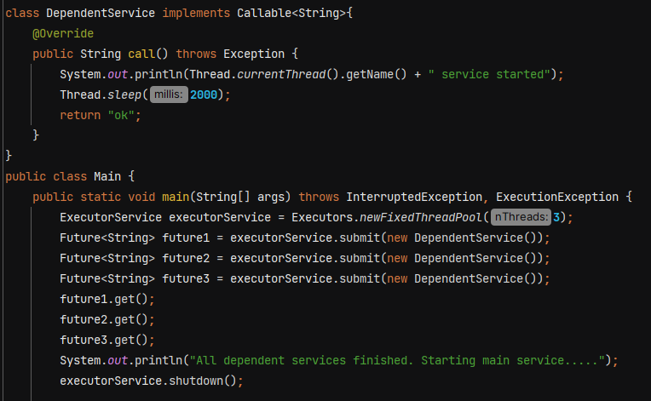

**With CountDownLatch -** 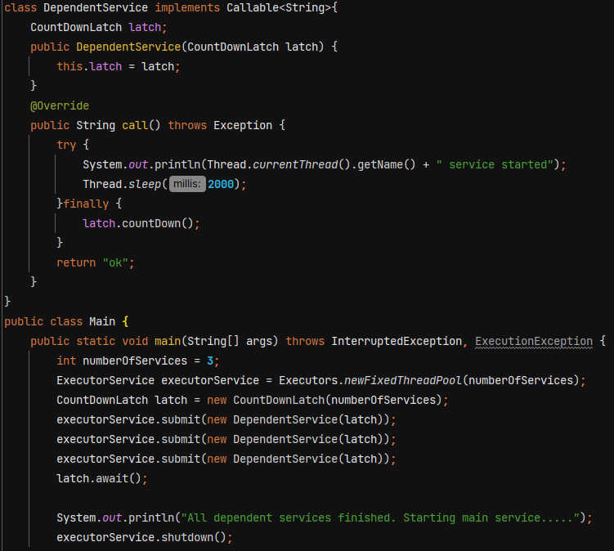

O/P 🡪 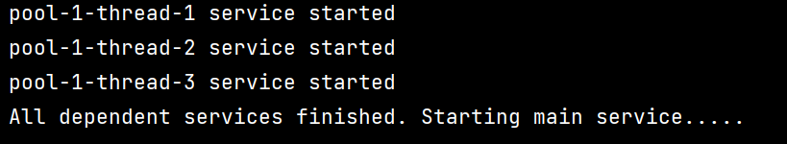

**Using threads –**

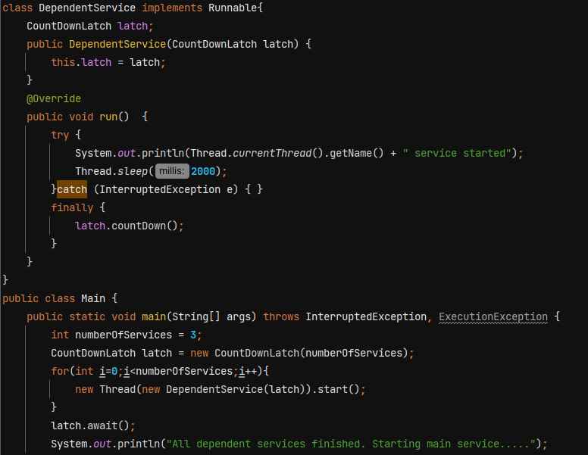

O/P 🡪 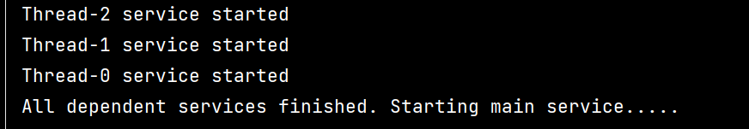

**await()** 🡺 Causes the current thread to wait until the latch has counted down to zero, unless the thread is interrupted.

We can also pass timeout in await()

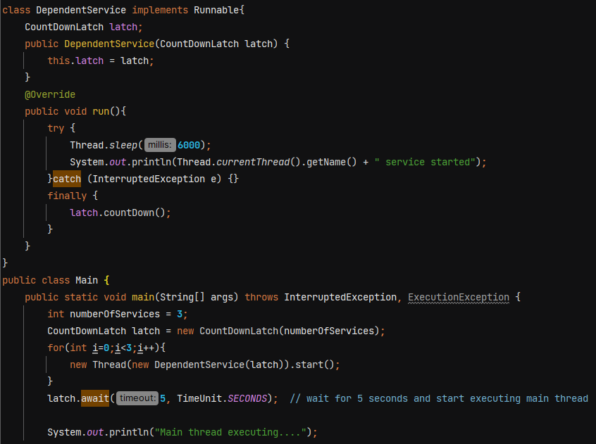

O/P 🡪 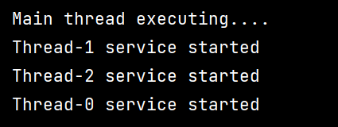

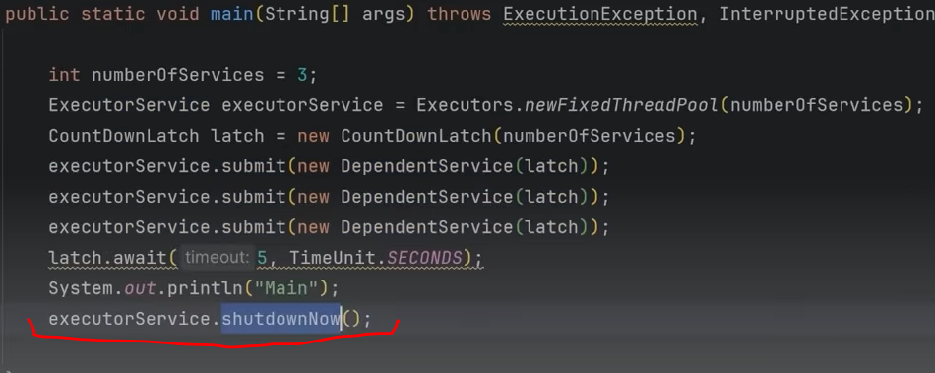

.shutdownNow() will terminate the worker threads immediately.

**CyclicBarrier** – It is reusable

CountDownLatch is not reusable, once the count reaches 0 it cannot be reset.

In cyclic barrier, multiple threads waits at barrier until all threads reached at barrier. When the last thread reaches the barrier then all threads are released. It does not block main thread. It is used to make sure that certain no of threads reach at a particular point before any of them proceed.

It automatically resets itself after all participating threads have reached the barrier.

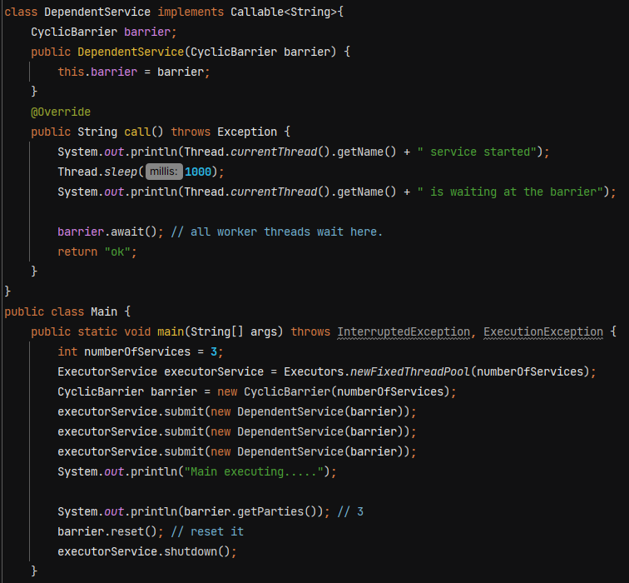

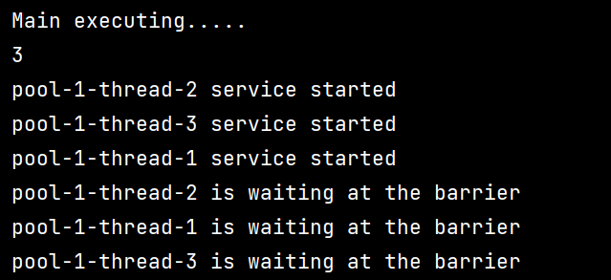

**await()** 🡺 Waits until all parties have invoked await on this barrier.

**getParties()** 🡺 Returns the number of parties required to trip this barrier.

**reset()** 🡺Resets the barrier to its initial state. If any parties are currently waiting at the barrier, they will return with a BrokenBarrierException.

Ex- image a big application having multiple subsystem

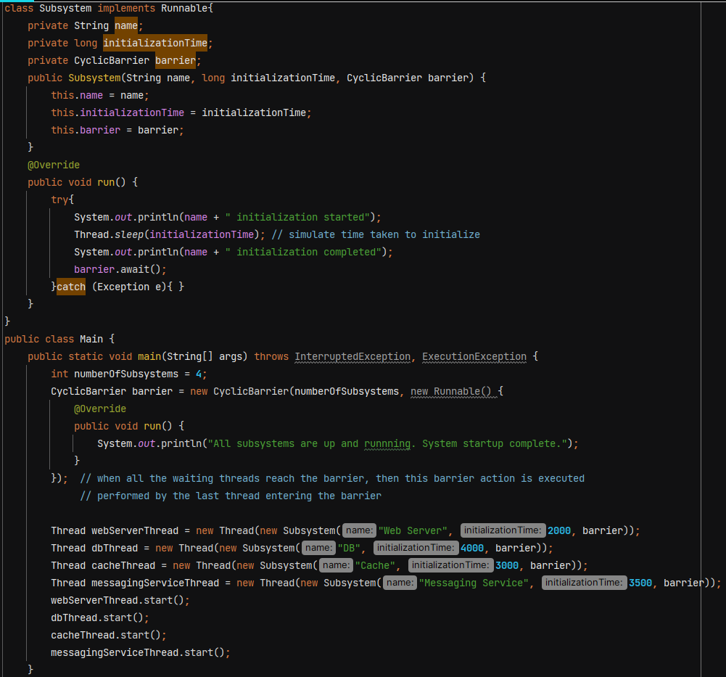

O/P 🡪 